Action Planner

Digital Marketing Strategy
Action Planner

Created by Boot Camp Digital
All Rights Reserved
Reproduction of this material is prohibited

What’s Inside the Guide:
This digital marketing action planner will help you to create a clear and effective digital strategy for your business or organization. The guide follows the process for building a strong digital strategy. In the guide, you’ll find:
WHAT’S INSIDE THE GUIDE: 2
STEPS TO BUILDING A DIGITAL MARKETING STRATEGY 3
STEP 1: LISTEN AND ASSESS THE LANDSCAPE 4
LISTEN TO CONSUMERS 4
LISTEN TO COMPETITORS 5
LISTEN TO THE CATEGORY OR INDUSTRY 6
STEP 2: DEFINING YOUR STRATEGY: GSOT 7
DEFINE YOUR GOAL 7
DEFINE YOUR STRATEGIES 8
DEFINE YOUR OBJECTIVES 9
STEP 3: IDENTIFY YOUR TARGET AUDIENCE 10
STEP 4: DEFINE YOUR CONTENT 11
STEP 5: DEFINE YOUR TOOLS AND TACTICS 12
THE DIGITAL MARKETING LANDSCAPE 12
CHOOSING YOUR TACTICS 13
PRIORITIZE TACTICS 14

Steps to Building a Digital Marketing Strategy

Building a digital marketing strategy involves 8 clear steps.

- Listen and assess the landscape
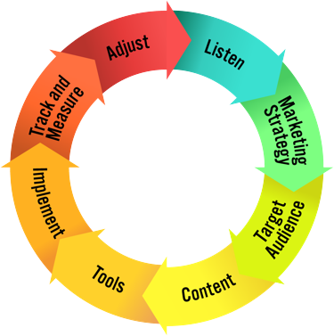
- Clearly define your strategies
- Understand your target audience
- Define your content
- Choose the tools & tactics to best meet your needs
- Implement with excellence and best practices
- Track & measure
- Adjust & optimize

This action planner will guide you through building a strategic digital marketing plan based on these 8 steps. At the end of this action planner you will have a clear digital marketing strategy for your business.

That being said, it is important to keep your strategy and approach agile to adapt to changes in digital marketing, your customers and to integrate learnings that you have along the way. For this reason, we recommend revisiting your digital strategy quarterly or semi- annually to re-think your strategy and adjust as appropriate.

This guide will focus on the first 4 steps in detail, and the 5th step at a higher level. Choosing your digital marketing tools, implementing with best practices and building a plan to track, measure, adjust & optimize should be a part of your digital marketing implementation plan for each tool that you are using.

This guide will help you to summarize these in the first 5 steps.

Step 1: Listen and Assess the Landscape

The first step is to listen and assess the landscape. There is more digital data freely available online than more people realize. Listening allows you to learn about your customers, competitors, your business and the category or industry.

A strong digital strategy starts with a clear understanding of what is already happening.

Listen to Consumers:
Where to Listen:

Google Search Results
  - Google Trends
  - Google Keyword Tool
  - Social Networks: Twitter, Pinterest, Instagram, Blogs, Niche Sites
  - Community Sites (based on your category)

Where are your consumers online?

What are they talking about?

What topics related to what you do are trending?

What needs and interests do they have related to your product or industry?

Listen to Competitors:
Where to Listen:

Search competitors across digital channels
  - Search engine results
  - Google trends
  - Google keyword tool
  - Social media mentions

Top competitors to evaluate (3 – 5):

What digital channels do your competitors use? (consider all channels – paid, earned, owned)

What are their strategies?

What do they seem to do right? What strategies are working?

What do they seem to do wrong? Where are they missing out?

Listen to the Category or Industry:
Where to Listen:

Search engine results
- Google trends
- Google keyword tool
- Social media mentions
- Discussion forums
- Blogs
- Niche industry sites
- Industry associations or news sites

What do people say about the category or industry? What questions do they have?

What content are they interested in related to the industry or category?

What content is popular? Why?

Who are the key influencers?

What media sites, accounts or people do they look to for advice or to have their questions answered?

Step 2: Defining Your Strategy: GSOT

Define your strategy with the GSOT method – Goals, Strategies, Objectives and Tactics. One of the biggest mistakes in digital marketing is starting with tactics and trying to make them fit into a strategy. Start with your goals and strategies to create a strategic digital plan that drives results.
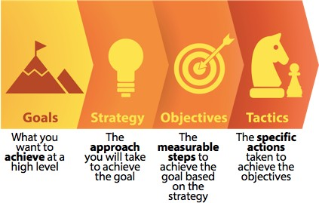

Define Your Goal

Start by defining your goals – on a high level, what do you want to achieve from your efforts in digital marketing? (NOTE: Brainstorm a list of possible goals, and choose one as your primary focus).

Define Your Strategies

You may employ multiple strategies to achieve your goal. Your strategies are the approaches that you use to achieve the goal.

It is helpful to consider your strategies at each stage of the digital path to purchase – ANCRA.
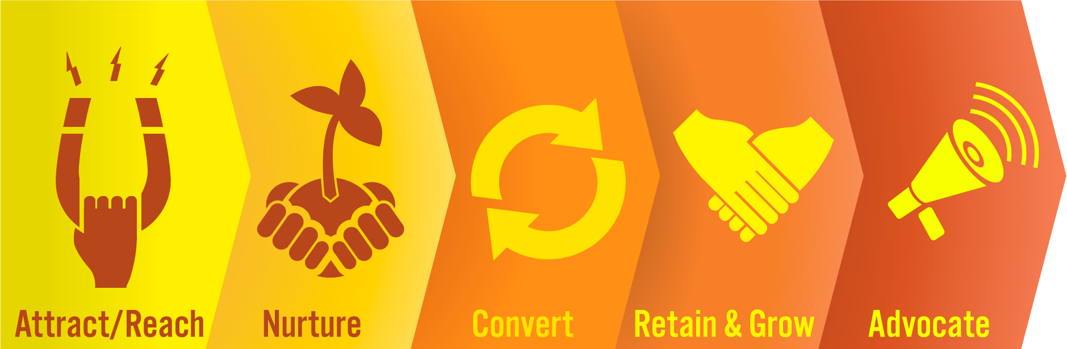

You may choose to focus on one or more areas of the path to purchase. Digital marketing can impact all of these 5 steps.

Start by brainstorming strategies for each step and circle your top 2 – 4 strategies that you want to focus your efforts around.

Attract/Reach

Nurture

Convert

Retain + Grow

Advocate

Define Your Objectives

Based on the strategies you selected you’ll now want to define your digital marketing objectives. These should be measurable things that you want to achieve as a result of your digital marketing efforts.

Choose approximately 1 – 4 objectives for each strategy. Use this space to brainstorm ideas and circle your best ones.
STRATEGY 1: OBJECTIVES:

STRATEGY 2: OBJECTIVES:

STRATEGY 3: OBJECTIVES

STRATEGY 4: OBJECTIVES:

Step 3: Identify Your Target Audience

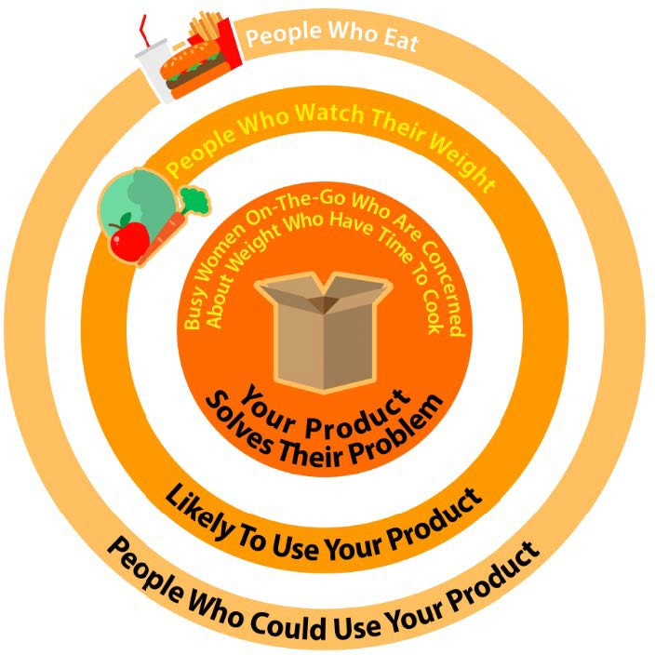
Clearly identifying your target audience is important since digital marketing allows us to reach audiences much more specific than what is possible in traditional marketing.

It is important to go beyond demographics when identifying your audience and start thinking about who they really are and why they use your product.

As you look to execute in digital marketing the better you’ve identified your target the easier it will be to execute.
Note: You may have multiple target audiences that you want to reach, which is fine.

Who is your target audience demographically?

What problem do you solve for them?

What are they interested in?

How do they behave online and offline?

Step 4: Define Your Content

Your content strategy should be based on both your business objectives as well as what your audience is actually interested in. Matching up content that achieves both of these is often the key to success in digital marketing.

With an increase in competitiveness for online attention, great (not just good) content is vital to your success.

What content is relevant to your business strategies?

What content does your customers/target audience care about?

What content topics overlap the 2 areas? What content is right for your digital strategy?

Step 5: Define Your Tools and Tactics

Each digital marketing tool that you use should have its own plan for specifically how you will use it and what it will achieve. That being said, it is helpful to step back and think strategically about the digital marketing tools at your disposal and how they can help to achieve your goals.
The Digital Marketing Landscape
As a refresher, the image below represents the digital marketing landscape and top tools/tactics used in each area. It is helpful to consider how each area may fit into your strategy.

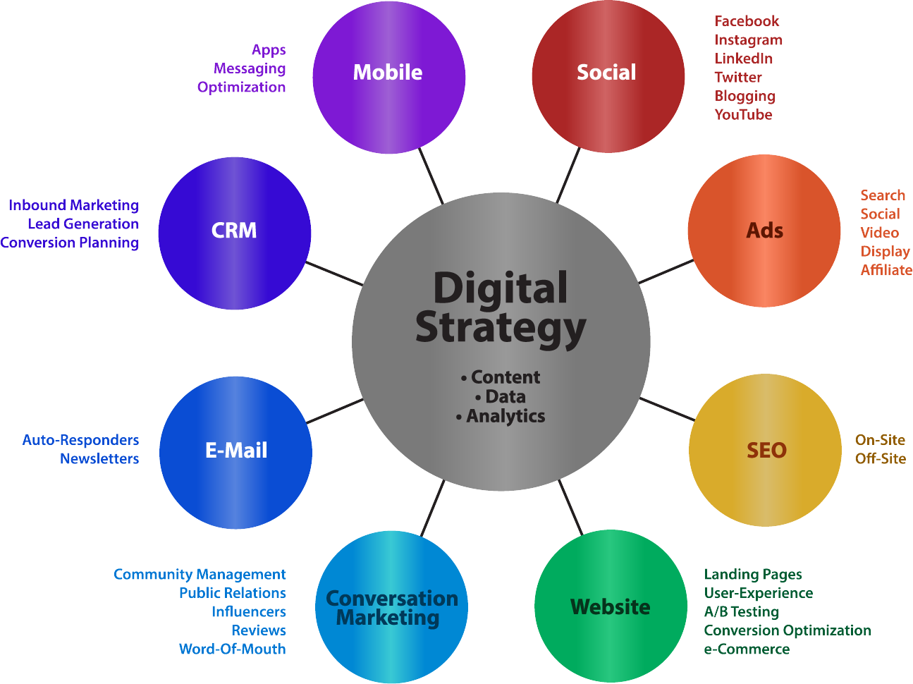

Choosing Your Tactics
Consider if and how each tool can help you to achieve your objectives. It is helpful to keep your objectives handy as you think about each tool and how it may fit.

Social – Facebook, Instagram, LinkedIn, Twitter, Blogs, YouTube

Ads – Search, social, video, display, affiliate

SEO – Onsite and offsite optimization

Websites – Landing pages, user experience, testing, conversion optimization, ecommerce

Conversation Marketing – Community management, PR, influencers, reviews, word-of-mouth

Email – Autoresponders, newsletters

CRM – Inbound marketing, lead generation, conversion planning

Mobile – Apps, messaging, optimization

Prioritize Tactics

There is almost no end to the digital marketing tactics that you can use to meet your strategic objectives. That being said, we all have limited time and resources.

Use the Hero, Hub, Hygiene model to prioritize your digital activities. Go back to the previous section and prioritize your tactics based on if they are Hero, Hub or Hygiene focused.

