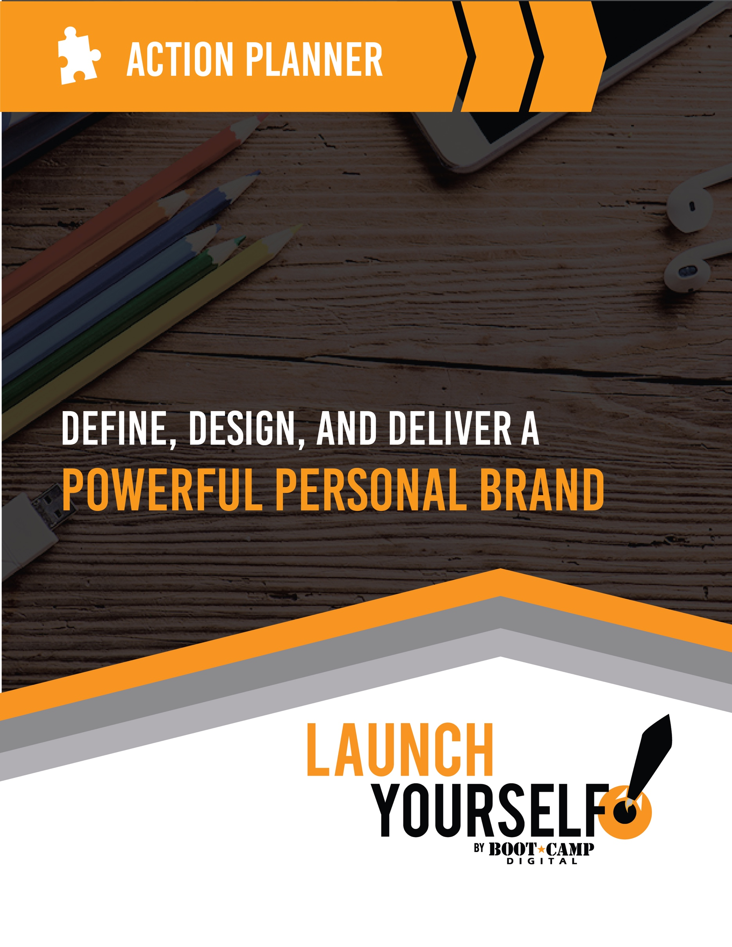

Table of Contents
Introduction
How to Use This Guide
Asses Your Current Personal Brand
Explore Yourself
Get Inspired
Part 1: Define
Define Your Personal Objectives
Determine Your Target Audience
Define Yourself Professionally
Define Your Personality
Define Yourself Personally
Crafting Your USP (Unique Selling Proposition)
Your Personal Brand Statement
Personal Brand Pyramid Overview
Crafting Your Brand Building Blocks
Establish Your Brand Character
Determine Your Mission
Craft Your Story
Part 2: Design
Design Your Look and Feel
Design Assets You Need
Complete Your Pyramid
Part 3: Deliver
Audit Yourself Online
Create a Personal Social Media Policy
Build Your Content Plan
Build Your Digital Presence
Social Network Plan
Social Network Plan: Example

Introduction

How to Use This Guide
This guide is your action planner to define (what are you about), design (make it compelling and desirable) and deliver (make it visible) a powerful personal brand. It is recommended that you follow the guide in order, however based on your objectives you can skip sections that aren’t relevant to you.

Keep in mind:

- You may not have all the answers now – Some of these are big questions and you may have a clear vision already or have a hard time formulating your answers. It is ok if you don’t have all the answers immediately.
- Keep moving forward – Don’t get hung up if you don’t have everything in place or are stumped by a specific area. Keep moving forward. If you need to, set yourself a timer on how long you will spend on each section and aim to complete it as best as you can in the time allotted.
- Your brand will evolve over time – Remember that your brand will evolve, change and grow over time (just like you). That is ok (and should happen). Pay attention to the feedback you get from your brand and start looking at others for ideas.
- Don’t try to do everything at once – As you look to bring your brand to life, don’t try to do to many things at once. Choose one thing, do it well and then add another. Investing in a few platforms or places to build your brand will bring you better results than trying to do many things at the same time.
- Put yourself out there – To bring your brand to life you’ll need to put yourself out there. While this may seem intimidating, keep in mind that for every person who knows more than you there are millions of people who know less and could benefit from what you know.

The most effective way to do it is to do it. – Amelia Earhart

AsseSs Your Current Personal Brand
The first step in defining a strong personal brand is to determine the brand that you have already created by evaluating how people perceive you and the messages you are currently sending out.

The focus on this section is to understand how you are currently perceived by others, not how you want to be perceived.

Power Tip:
Sometimes we don’t see ourselves as clearly as others see us. It can be helpful to ask other people for their opinions, for example close friends, a coworker or even your supervisor. Your goal is to get feedback to help you to see your current brand as well as the strengths that you can harness in bringing your personal brand to life.

How Other People Perceive You

When people describe me personally, the top words they use are (these should be personality traits):

When people describe me professionally, the top words they use are (these should be characteristics and personality traits vs. skills):

What top words would your boss (or a former boss) use to describe you?

How do I benefit the people working with me?

How do I make people feel?

When you meet a new person, what do they remember about you?

Ask your close coworkers, friends and clients to write a short 5 sentence bio about you, as though they were introducing you as a professional speaker, or as a winner of an award. Take note of what they say and how they position you. What do you like? What would you change?

Test Your Current Brand

Attend a networking event, or another event where you will meet other professionals. Introduce yourself to someone new and spend a few minutes chatting with the person. Next excuse yourself from the conversation.

Wait 5 minutes and have a friend start a conversation with the new person you just met. Have them ask the new person about you “Hey, I noticed you were speaking to Krista earlier, what does she do?”

Take note of what they remember and how accurately they are able to share who you are and what you do. This helps you understand if your brand message is memorable. Do this over and over again as you grow and evolve your brand to test the effectiveness.

Explore Yourself
Prior to defining yourself it can be helpful to spend some time in self-exploration. The exercises in this section are designed to help you think about yourself, your strengths and your skills. The idea of this section is to get your creative juices flowing.

What are your top skills? Choose 6 and rank them in order.

- Analyzing numbers
- Attention to detail
- Brainstorming
- Budgeting
- Building consensus
- Building reports
- Coaching
- Communicating
- Conflict management
- Counselling
- Creating
- Creativity
- Customer focus
- Decision-making
- Delegating
- Delivering results
- Designing
- Developing ideas
- Empowering others
- Establishing metrics
- Facilitating
- Finding solutions
- Forecasting
- Group leadership
- Identifying problems
- Innovating
- Inspiring others
- Interviewing
- Inventing
- Investigating
- Learning new skills
- Managing conflict
- Managing crisis
- Managing budgets
- Managing people
- Managing projects
- Managing time
- Management communication
- Measuring success
- Mediating
- Motivating
- Negotiating
- Organizing
- Performing analysis
- People skills
- Presenting
- Prioritizing
- Problem-solving
- Professional growth
- Public speaking
- Quantitative analysis
- Relationship building
- Reporting
- Researching
- Running meetings
- Scheduling
- Selling
- Solving problems
- Sourcing talent
- Storytelling
- Teaching
- Team building
- Thinking
- Teaching
- Thought leadership
- Training
- Visioning
- Writing
- Other

What are your top StrengthsFinder Strengths? Find a list here https://high5test.com/test/

1.

2.

3.

What are your top personal attributes? For example:

- Accomplished
- Accurate
- Adaptable
- Adventurous
- Ambitious
- Analytical
- Assertive
- Big personality
- Bold
- Bright
- Charming
- Charismatic
- Cheerful
- Collaborative
- Colorful
- Community-oriented
- Competitive
- Confident
- Connected
- Conservative
- Considerate
- Consistent
- Convincing
- Creative
- Curious
- Dependable
- Devoted
- Diplomatic
- Discerning
- Dramatic
- Driven
- Dynamic
- Easygoing
- Empowering
- Energetic
- Engaging
- Enterprising
- Enthusiastic
- Entrepreneurial
- Ethical
- Excited
- Extroverted
- Flexible
- Formal
- Friendly
- Funny
- Generous
- Giving
- Happy
- Healthy
- Honest
- Humble
- Inspiring
- Intelligent
- Interested
- International
- Introverted
- Inventive
- Kind
- Likable
- Loving
- Loyal
- Methodical
- Modest
- Motivating
- Optimistic
- Organized
- Outgoing
- Passionate
- Perky
- Personable
- Persuasive
- Picky
- Political
- Positive
- Powerful
- Precise
- Proactive
- Productive
- Professional
- Quick-witted
- Quirky
- Refined
- Reliable
- Risk-taking
- Sassy
- Savvy
- Self-assured
- Self-motivated
- Sensitive
- Shy
- Sincere
- Skeptical
- Slick
- Socially conscious
- Sophisticated
- Spirited
- Spiritual
- Steady
- Strategic
- Striving
- Suave
- Successful
- Supportive
- Thoughtful
- Trustworthy
- Visionary
- Wise
- Witty
- Worldly
- Zen-like
- Other
If you were participating in a team, what role would you most likely be successful in?
- Administrator (managing tasks, responding to questions, keeping everyone informed)
- Care giver (all members of the team are happy, engaged and cared for)
- Creator (comes up with creative ideas about what to do and how to do it)
- Does (executes part of the project)
- Facilitator (orchestrates and coordinates the group to achieve its goals)
- Leader (creates a vision, assembles team, takes charge, measures progress)
- Motivator (inspires others to do their best and be successful)
- Project Manager (manages budget, people, schedules, keeps organized)

What is your personality type? Take a free online, Myers’ Briggs analysis – what are the results – did anything surprise you? http://www.humanmetrics.com/cgi-win/jtypes2.asp (free online assessment)

If you were a ___________ which one would you be?

- Car
- Cereal brand
- Animal
- Donut
- Cartoon character
- Movie star
- TV Character

I know I am in my element when ___________________________________________.
(what you love)

People recognize my expertise/knowledge in ________________________________.
(What you are good at/the skills that you possess)

People comment on my ability to ___________________________________________.
(What sets you apart)

Get Inspired
As you embark on your personal branding journey it is helpful to get inspired by others. They could be business professionals you admire, celebrities, others in your industry, people in your organization or industry thought-leaders that you follow and learn from.

Who are 3 - 5 people you admire? What do you like about their brand?

Who are 3 - 5 people in your industry that you follow? What do you like about their brand?

Who are 3 - 5 people that are achieving for themselves what you want? What do you like about their brand?

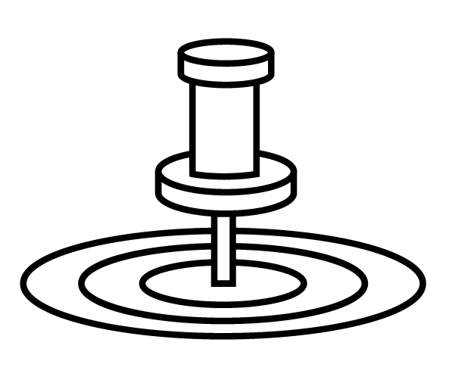

Part 1: Define

Define Your Personal Objectives
In order to craft a personal brand it is helpful to understand why you are creating your brand and what you want to achieve with your brand.

Where do you want to be professionally in 5 – 10 years?

Why are you creating a personal brand?

What do you want to gain from your personal brand?
(prioritize these or add your own)

- Book deals
- Speaking
- Clients
- Sales
- Job offers
- Become a coach
- Expert opportunities
- Press opportunities
- A promotion at work
- Improved perception at work
- Career change
- Start a business
- Become an industry leader
- Become an influencer
- Board positions
- Get a teaching position
- Become a consultant
- Sell a product
- Share your knowledge
- Promote and/or advocate for your company
- Run for office
- Share your passions
- Build a business
- Get published in industry publications
- Get funding for a startup
- Manage your reputation in a public position
- Achieve recognition at work
- Other: _________
- Other: _________

Determine Your Target Audience
It is helpful to understand the target audience you want to reach with your personal brand. While this may not seem like an important step, knowing who you want to reach will bring additional focus to your personal brand – especially as you bring it to life online.

Who is the main audience that you want to reach?

Who influences them? Who do they follow?

What about your existing audience – who are you already connected to that can help?

- In your industry?
- Clients?
- Prospects?
- Sr. Managers?
- Influencers?
- Specific groups (press, etc.)

Define Yourself Professionally
Your professional definition helps you to brainstorm and evaluate your professional strengths and positioning. While there may be many in your profession defining yourself professionally will help you determine where you focus and what makes you unique.

What field or industry are you in or do you want to be in? What are the words used to describe your work or industry?

How can you more specifically define my talents into a niche?
Can you be more specific about what you do – for example vs. a Lawyer you are a trial lawyer who specializes in civil disputes with a strength in jury assessment.

What are the core skills for what you do?

How do you do your job better/differently than others in your profession?

What sets you apart from others who do what you do?
What are your greatest professional strengths?

What are you best at?

What do you love the most about your job or what you do? (This could be functional – solving complex problems – or emotional – helping people)

What experiences do you have that make you stand out? (experience, clients, courses, programs, employers, education)

What do you do? ___________________________________________.
(professional description – clear, simple, no jargon, easy to understand)

What is the solution that you provide? ________________________________.
(professional solution – how do you help people, what do they get, logical + emotional)

What is the benefit from what you do? ___________________________________________.
(professional benefit – what is the benefit that someone gets, what is unique about you)

Define Your Personality
Defining your personality is about focusing on the areas of your personality that you want to bring across with your personal brand. It isn’t just about examining your personality, but also about choosing the aspects of your personality that you want to let shine in your personal brand.

It may be helpful to also re-examine some of the people you reviewed earlier to evaluate the elements of their personality that shine through. People connect with people – so getting your personality across is key.
Remember:
A brand connects with hearts and minds.

What is most memorable about you? When people meet you, the thing that they remember is _________________________________________________________________________________ (this could be personality, physical, trait, behavior, etc.)

People like to work with me because:

My friends would say that my personality is:

The aspects of my personality that I want my brand to portray are (choose 2 - 4):

Define Yourself Personally
People connect with PEOPLE and building connections with people involves exposing parts of your personal life as well as your professional life. One of the best ways to connect with people is through commonalities – which often link back to our personal interests or hobbies. These can also be memorable and set you apart from others.
The most successful personal brands reveal and share parts of their personal lives based on the image they are trying to craft. Consider what makes you interesting beyond your work to make your brand more relatable and interesting.

What are your passions? These can be both personal and professional. If you had nothing else to motivate you, what would you get out of bed at 5am for every day?

What are your personal values?
For example: Balance, being the best, agility, calmness, challenge, decisiveness, perseverance, drive, honesty, integrity, pragmatism, sensitivity, structure, teamwork, sharing, vitality, zeal.

What are your hobbies? What do you like to do in your free time?

What interesting things have you done or accomplished personally? What are you most proud of?

Crafting Your USP (Unique Selling Proposition)
Your USP or Unique Selling Proposition is what makes you unique – what is it that really makes you different vs. others. Brands focus on driving awareness around their unique selling proposition and your personal brand should do the same.

As you consider all of the exploration you’ve done in the last few sections, it is time to bring it together into a USP.

What makes you unique at what you do? Brainstorm ideas and circle the one or two that you want to focus on.

- How do people benefit from your solution?
- What do you do better or faster?
- What makes you better to work with vs someone else?
- How do you approach your work differently?
- Are there parts of your personality that set you apart?
- Do you have credibility or specialization that makes you unique?

Your Personal Brand Statement
Congratulations – it is time to summarize your work in the Define stage by crafting your personal brand statement. This should be a summary based on the previous sections. A few tips to evaluate your personal brand statement:

- Avoid jargon or “marketing” type of words
- Make sure that it is understandable to your target audience
- Be sure that it makes you unique vs. your peers
- Check that it is authentic to you – don’t try to be someone you aren’t
- It should get you excited!!!!!
- Don’t worry if you don’t have it perfect – this is just for you to give you focus. Do your best for now and you can always revise it later.
Power Tip:
If you are struggling or not sure if you have it right, run it by some close family, friends or colleagues. Sometimes other people see things you can’t and they may shine a light on your hidden talents or USPs.

My goal from my personal brand is:

I am (professional description):

Who is (personality and USP):

And helps people (professional solution):

So that (professional benefit):

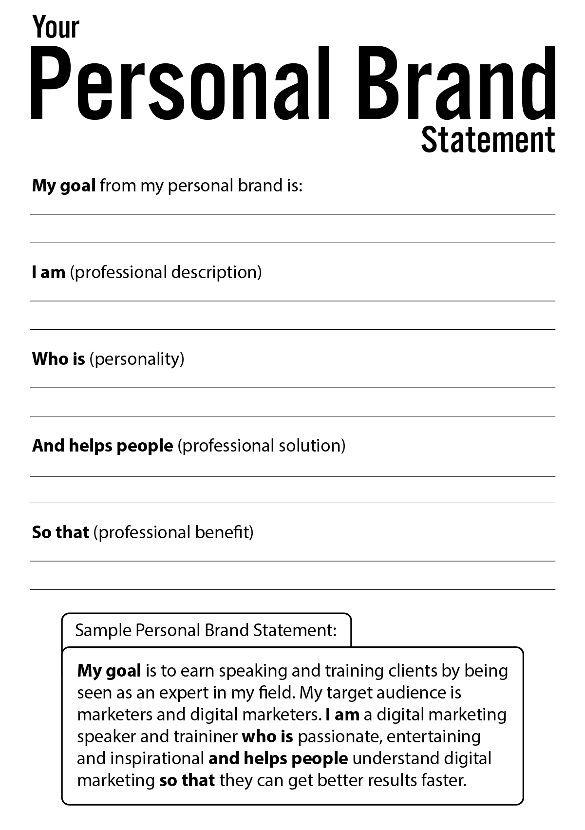

Example:
My goal is to earn speaking and training clients by being seen as an expert in my field. My target audience is marketers and digital marketers.

I am a digital marketing speaker and trainer who is passionate, entertaining and inspirational; a bestselling author and global speaker and helps people understand digital marketing so that they can get better results faster.

Personal Brand Pyramid Overview
Designing your personal brand is about crafting a personal brand that draws people to you – it should create a compelling reason for people to want to work with you and generate desire or interest. This personal branding pyramid is based on how the world’s largest brands are built.

A brand speaks to hearts and minds, so it is important to remember the human connection and not only focus on the professional aspects of your brand. In this section you will craft your own personal brand pyramid.
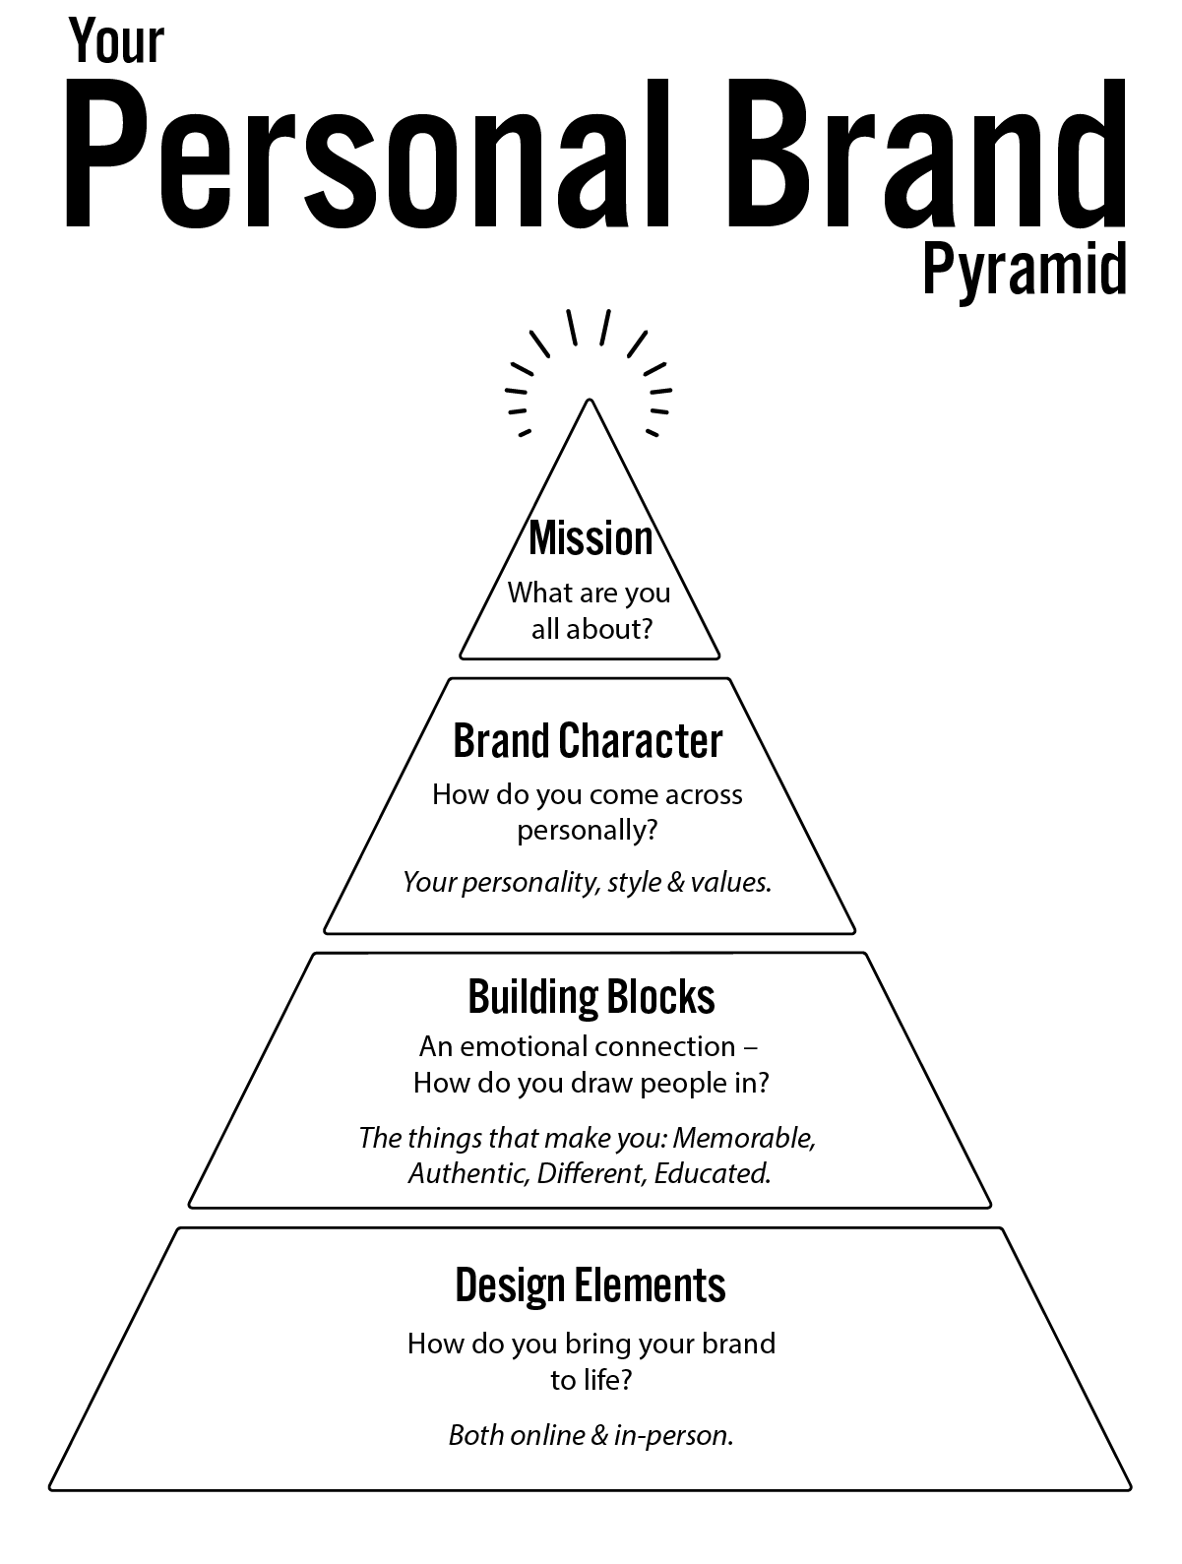
Remember:
This is a journey – you may not have all of the answers perfect right now. That is ok. Continue to move forward and get as close as you can. Your brand will grow and evolve over time, so nothing is set in stone.

Crafting Your Brand Building Blocks
There are 4 core elements of crafting a brand that stands out – it should be memorable, authentic, different and educated (MADE) – these are the building blocks of your brand. The objective of this section is to choose 5 – 10 things that you want to bring to life with the execution of your personal brand. This is your roadmap on how you will execute your personal brand.

Ideally, you’ll have at least 1 from each section to balance how you execute your brand across the principles of success.

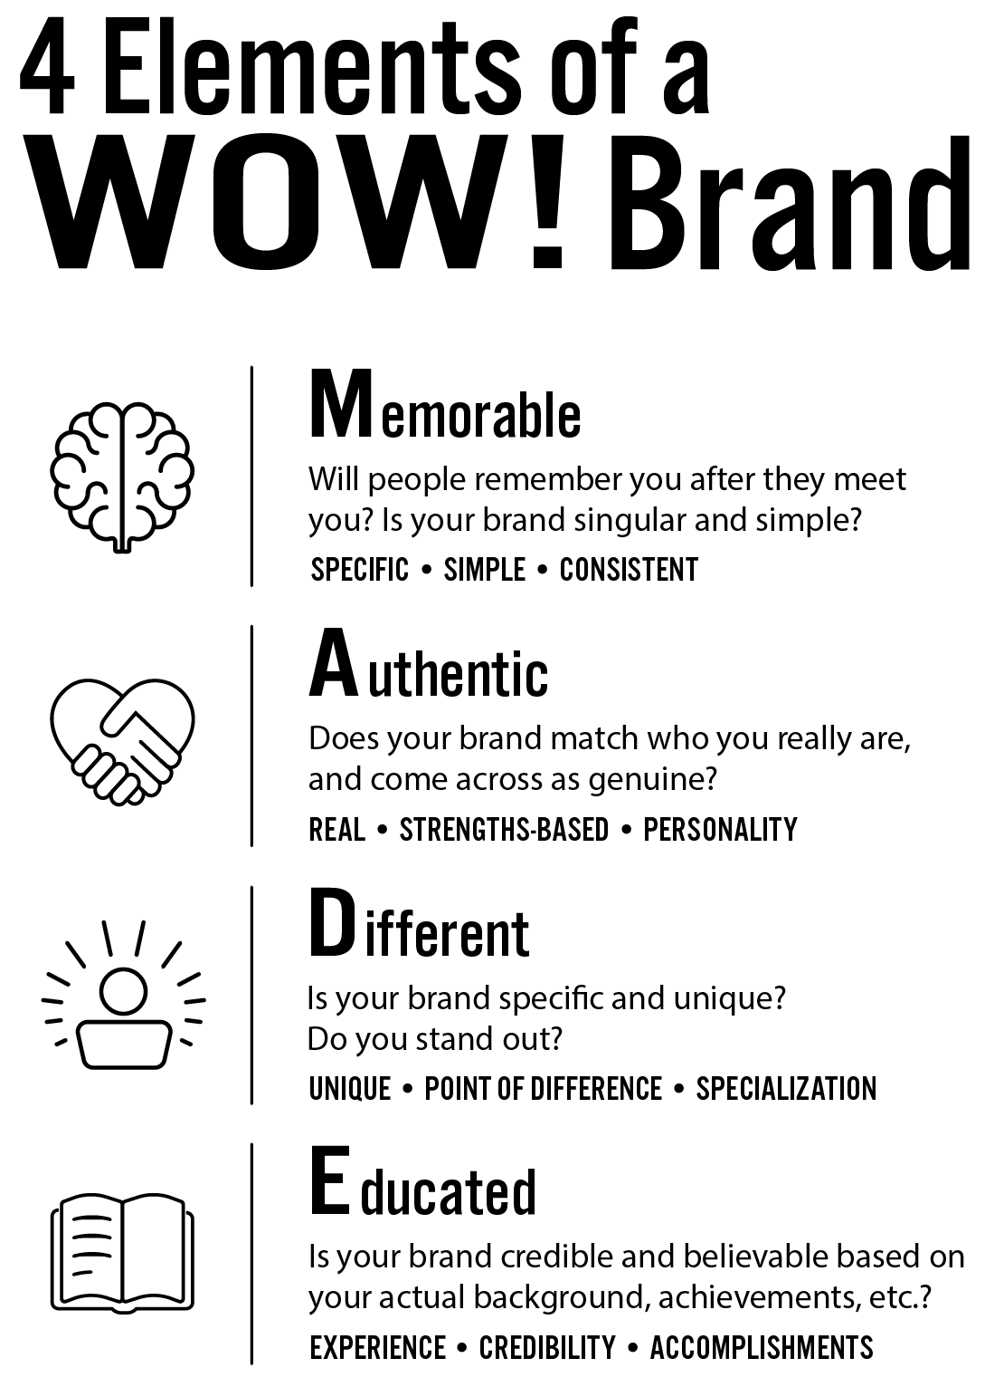

Memorable

A memorable brand is specific, simple and consistent. These principles are important to keep in mind as you bring your personal brand to life with your execution, but also helpful to build in to your plan for your personal brand.

Consider some of the memorable or distinctive things about you that you want to portray in your personal brand execution. Your goal here is to come up with 2 - 4 things to highlight that increase your memorability.

Note: You may also go back and improve your personal brand statement based on these principles.

Specific: How can you define what you do as specifically as possible so that you are the best in your area or distinctive in your focus. What do you do that is specific?

Simple: What you do and how you help people should be simple to understand. Complexity or jargon tend to confuse people – and make you less memorable. If someone doesn’t know what you do, how can they share what you do?

Consistent: Your personal brand should be executed as consistently as possible. What are the elements of your brand that are most memorable that you want to consistently deliver? This could be physical, personality, message, etc

What are the 1 – 4 elements of your brand that are most memorable that you can incorporate into how you design and deliver your brand online.

Authentic

An authentic brand builds connections with people and breaks through because it is real, strengths-based and personality driven. The goal of an authentic brand is to harness YOU and YOUR STRENGTHS in how you execute your brand.

Note: You may also go back and improve your personal brand statement based on these principles.

Real: Your personal brand should come across as real – not contrived or like a press release. What are real elements of your life or personality that you are comfortable sharing? This could be hobbies, interests, day-to-day activities. These could be both personal and professional. For example, professionally I share training programs I am running and interesting marketing examples I find. Personally, I share my traveling, passion for beverages (coffee, wine and martinis – in no particular order) and productivity tips.

Strengths-based: Focus your brand on your strengths. What are some of your strengths that you want to bring across to people Choose 1 - 3 personal strengths that you have professionally that will differentiate you from others.

Personality: A strong personal brand is liked by people – and people like people based on their personality. How do you want your personality to come across? What are some aspects that you want to bring to life in your personal brand?

What are the 1 - 4 elements of your brand that are most authentic that you want to incorporate into your personal brand?

Different

In order for a brand to stand out, it must be unique or different. From a business strategy standpoint, niche businesses tend to be more effective vs. broad businesses, yet as individuals we often fail to define ourselves specifically. We want to highlight everything we can do instead of focusing on what we really do best.

If you needed a photographer for your wedding, would you rather hire (and pay more) for a photographer who specialized in weddings and could give you a detailed wedding plan or a photographer who could also shoot your business product photography, headshots, pets, concerts and stock photography?

You will be more successful if you create a distinctive personal brand (and you can probably demand a premium).

Note: You may also go back and improve your personal brand statement based on these principles.

Unique: What are some of the things that make you unique or different vs. others in your industry? What can you highlight to be more distinctive?

Point of Difference: What are some of your points of difference vs. others? This could be experience, qualifications, approach, personality, etc. Why would I choose you over someone else?

Specialization: Consider specializing to be different. For example, there are hundreds of thousands of social media managers, but only a few specializing in restaurants. How can you specialize yourself to be “the best” at something specific?

What are the 1 – 4 elements of your brand that are most different that you want to incorporate into your personal brand?

Educated

An educated brand focuses on the elements that build your credibility. You’ll want to get these elements across to people to validate your personal brand and come across as believable. For example, if I am the best at social media for restaurants, what are some proof points I have that demonstrate this? What experience, credibility boosters or accomplishments make this believable?

Depending on where you are in your career and your personal branding journey you may have different credibility builders. Everyone starts out with only a few but over time, you’ll add more to your list. Look at other people to see what they highlight about themselves that sounds impressive and see if you have similar content.

Note: You may also go back and improve your personal brand statement based on these principles.

Experience: What relevant experience do you have that builds your credibility? This could be things like length of experience, key accomplishments in roles, client lists, well-known employers, successful projects, awards at work, partners you worked with, etc.

Credibility: Are there other credibility boosters you can highlight? This could include things like contributing to articles or books, celebrity associations, participating in an association or events, media appearances, the scope of your work (for example, International).

Accomplishments: Do you have key accomplishments that you can highlight to grow your credibility and believability? This could be things like awards, books or publications, speaking engagements,

What are the 1 – 4 elements of your brand that are most credible that you want to incorporate into your personal brand?

Refining Your Building Blocks

Based on the ideas from your MADE (Memorable, Authentic, Different and Educated) brainstorming above, choose 5 - 10 key elements that you want to highlight. Based on your personal brand objectives there may be different sections that are more relevant to you.

For example, if your aim is to become a coach, building a personal connection is really important, so you may focus on the A bucket and the D bucket to differentiate yourself in a crowded marketplace. If your goal is to gain a promotion where you work, you may aim to focus on the D and E to standout more vs your peers. If you want to increase sales, you may focus on A and E to build relationships and establish your credibility as a thought leader.

Aim to choose no more than 10, and fewer than 5 is ok as well. Try to incorporate 1 element from each of the MADE elements to craft as strong a brand as possible. You may notice some overlap in your ideas, which is ok as well.

Write down the key 5 - 10 building blocks that you want to bring to life with your personal brand.

Establish Your Brand Character
The next step on the pyramid is the brand character – this is what your brand looks and feels like. Don’t think of this as a character that you play, rather how you want to be perceived. Consider the differences in character between Steve Jobs and Bill Gates or Martha Stewart and Rachel Ray.

It is helpful to consider the tone of voice or character that you intend to create upfront, as it will help to guide you through the choices in how you execute your brand. You may also realize that the character you want to have and where you are now are farther away than you realized.
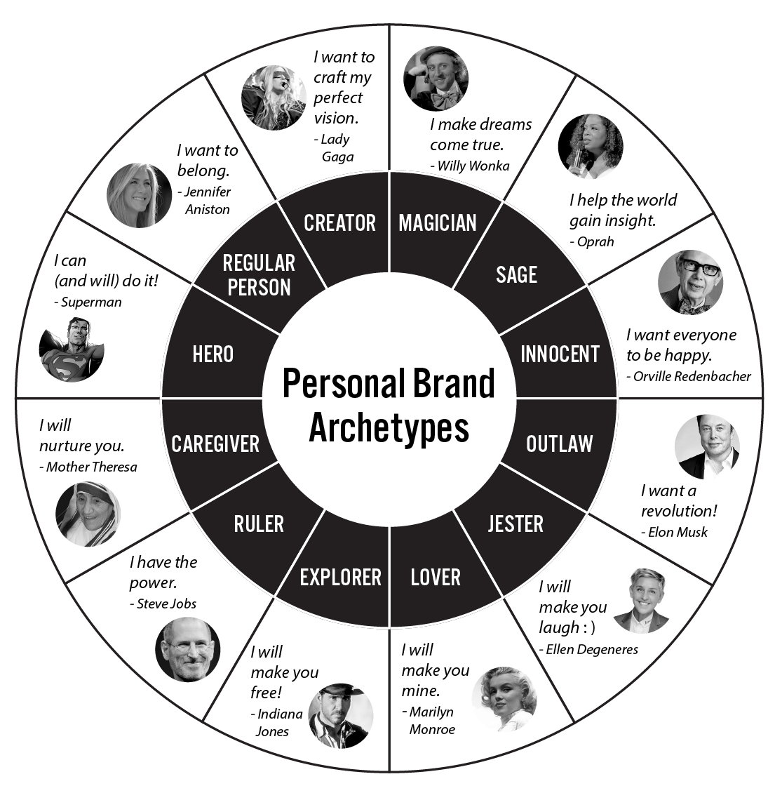
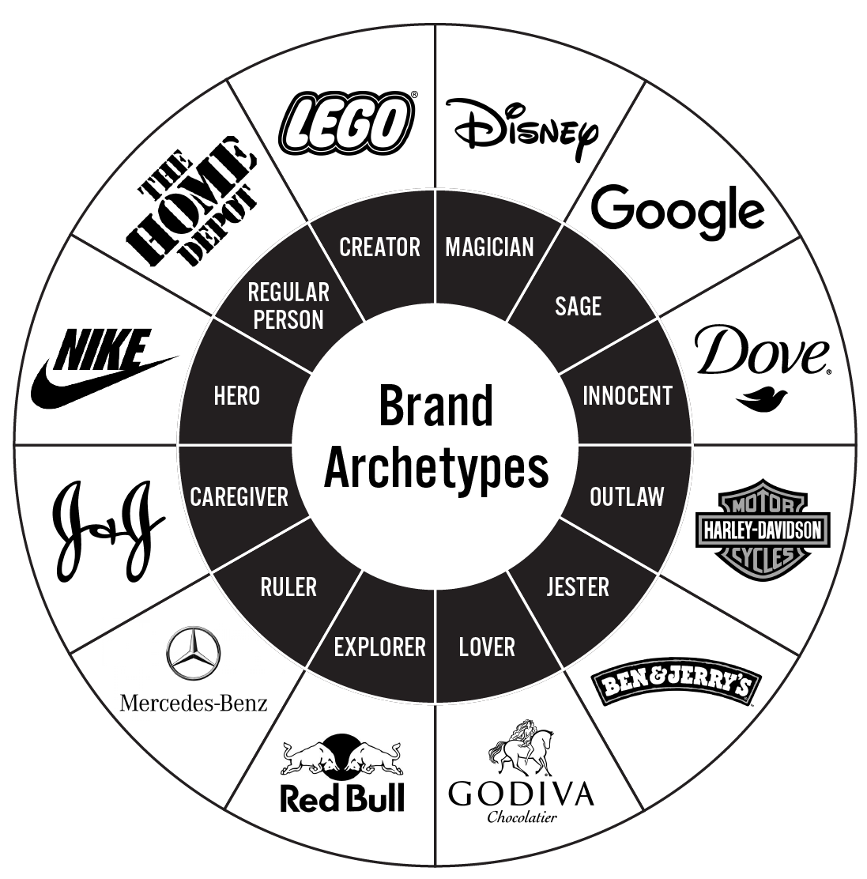
What brand archetype are you? Why?

What tone of voice will you use? What type of language is appropriate? Direct and to the point? Storytelling? Funny? Raw?

How should people FEEL after interacting with you and your personal brand?

If your brand was a celebrity or TV character, what would it be?

Determine Your Mission

Once you know your building blocks – the foundation of what makes your brand compelling – and your character – the look and feel of your brand – the next step is to craft a MISSION! The mission is what gets you out of bed in the morning. What gets you excited. Why you do what you do.

A mission is something that inspires others to join you!

If you want to craft a really strong brand, it should speak to others in a way that drives them to want to help. This is usually about reframing why you do what you do. For example, I do training to help businesses get better results faster. That focuses on what I do and the benefit. But why do I do this?

The why is your mission.

A great mission will create an emotional connection.

Look back at your personal brand statement – you will probably find that it is fairly functional.

I am a digital marketing speaker and trainer who is passionate, entertaining and inspirational; a bestselling author and global speaker and helps people understand digital marketing so that they can get better results faster.

The goal of the mission is to add to it in an emotional and inspirational way so that you have a clear purpose that has a broad benefit to others and encourages them to join you.

What value do you bring to the world?

What can other people get behind?
How can you inspire others to join you?

In a perfect world, what you would want to achieve that would benefit the world?

Craft a short mission to add to the end of your personal brand statement.
The more specific the mission is the better – for example I want to help 1 million small businesses to grow is more compelling than I want to help small businesses grow.

- Make software that improves productivity of workers by 50% (programmer)
- Help 1 million small businesses thrive (consultant)
- Give financial stability and a safety net to 1,000 people (financial planner)
- Empower people to live their dreams today with a proven plan (financial planner)

Craft Your Story

People remember stories more than anything else. As you bring your brand to life you’ll meet people, give presentations and share content online. In all of these places it can be helpful to have a “story” for yourself. Your story is basically how you got to where you are.

People remember stories more than anything else.

Your story should help people to relate to you and understand how you got to be where you are and why you love it. Consider the journey that brought you to where you currently are?

Your story should end with your mission and explain your why.

How did you get to where you are?

Who inspired your journey?

What made you decide to do this? What was your turning point?

Why are you on the mission you’re on? What prompted it?

Craft your story:

Part 2: Design

Design Your Look and Feel
Determine the look and feel that you want your brand to have. Based on your brand pyramid how do you want to bring your brand to life. This should include:
- How you look
- What you wear
- The overall style
- Your “look”

What profile pictures do you have that represent the look you want?

What is your PERFECT outfit and style to embody your personal brand?

What fonts, colors and design elements represent the brand that you want to create?

What images, quotes or visuals embody the style you want to show?

Create a visual board (using image searches or Pinterest) of inspiration for the look and feel that you want to create.

Design Assets You Need

In order to effectively bring your brand to life online, you’ll need to have a few basic design elements ready to go. Deliberately crafting these upfront will help you to be sure that you are deliberately bringing your brand pyramid to life online in a consistent and effective way.

Consistency is one of the keys to success for a powerful personal brand – so delivering your brand consistently is key.

The assets that you should craft in advance are:

- Bios:
  - 140 Characters
  - 1 Paragraph
  - 3 Paragraphs
- Tag Line
- Pyramid (MADE elements)
- Photo/image
- Business card
- Color scheme
- Font
- Logo (optional)

Complete Your Pyramid
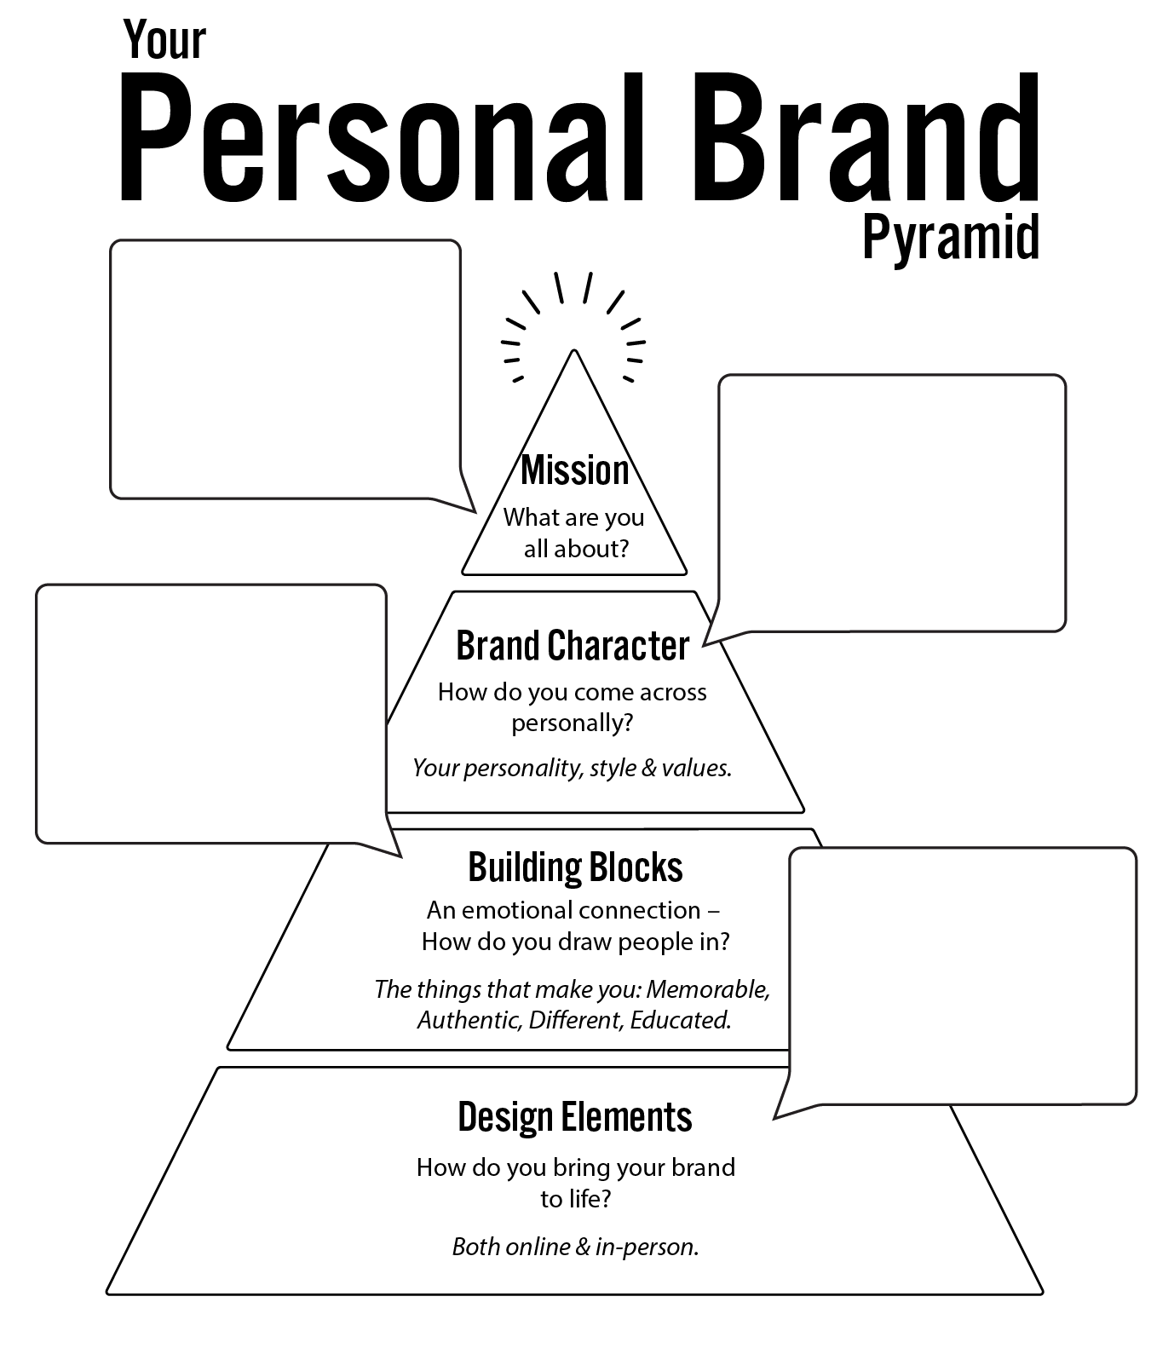

Part 3: Deliver

Audit Yourself Online
A good first step in assessing your personal brand is to audit yourself online to step back and take an objective look at what you are already putting out there. It is helpful to step back and evaluate your brand as someone who doesn’t know you.

Google Yourself. What do you find? Good? Bad? Neither? What are the opportunities to improve?

Google some industry thought-leaders. What do you find? What shows up for them that doesn’t show up for you?

Look at your social networks. What is your current content balance? What perception would someone have about you? How much content is positive vs. negative? What content topics are you currently posting about? Any content that is not appropriate?

PowerTip:
Create a Google alert for your name at https://www.google.com/alerts
to be notified when your name is mentioned online.

Start, Stop, Continue
Create your Start, Stop, Continue list – what should you start doing, what should you stop doing and what should you continue doing? You can create a separate list for each social network. Keep in mind that you will likely add to this list (especially the start section) as we dive in to best practices for social networks.

Start | Stop | Continue

Create a Personal Social Media Policy
As you seek to control your online personal brand, it can be helpful to craft a personal social media policy. Businesses have social media policies so that employees don’t post inappropriate things online.

It may be helpful for you to create a social media policy for yourself to be sure that you aren’t posting content online that can work against you.

What times of days are off-limits for posting?

How do you feel about posting pictures with alcohol? Or drugs?

Is certain content not appropriate for weekdays?

What language is off-limits?

What is your guideline for political posts?

What are your privacy settings (and what should they be) for different networks?

What work-related content is off-limits?

Are there specific work-related areas to be aware of?
(client privacy, HIPPA, complaining about customers, discussing work-related events, confidentiality, etc.)

Any other off-limits topics?

Do you want to limit negativity in your content?

Is complaining about businesses or people off-limits?

Do you need to set any expectations with your friends?

Is there anything else to add? Any pitfalls to avoid?

Build Your Content Plan
Prior to getting active in building your brand online it is helpful to create a content plan that outlines the type of content you will post (and frequency) to bring your personal brand to life in a deliberate way.

Review your Personal Brand Pyramid and remember the MADE principles as you think through the content that will work best for you. Balance professional and personal content.

Create your content plan. Aim to have 4 - 8 content buckets or topics that you will talk about.

Content Topic | % of Content | Format & Channel | Sample Posts/Ideas
Personal productivity tips | 20% | Video  LinkedIn, Facebook, YouTube | - 5 Things I do EVERY morning to start strong  - How to minimize distractions and stay focused  - The email strategy that changed my life

Build Your Digital Presence
When it comes to building your digital presence you’ll want to focus your efforts on the social networks that are most likely to bring you the results that you want.

Start by reviewing the chart below which highlights the value of each social network or why you would use it.

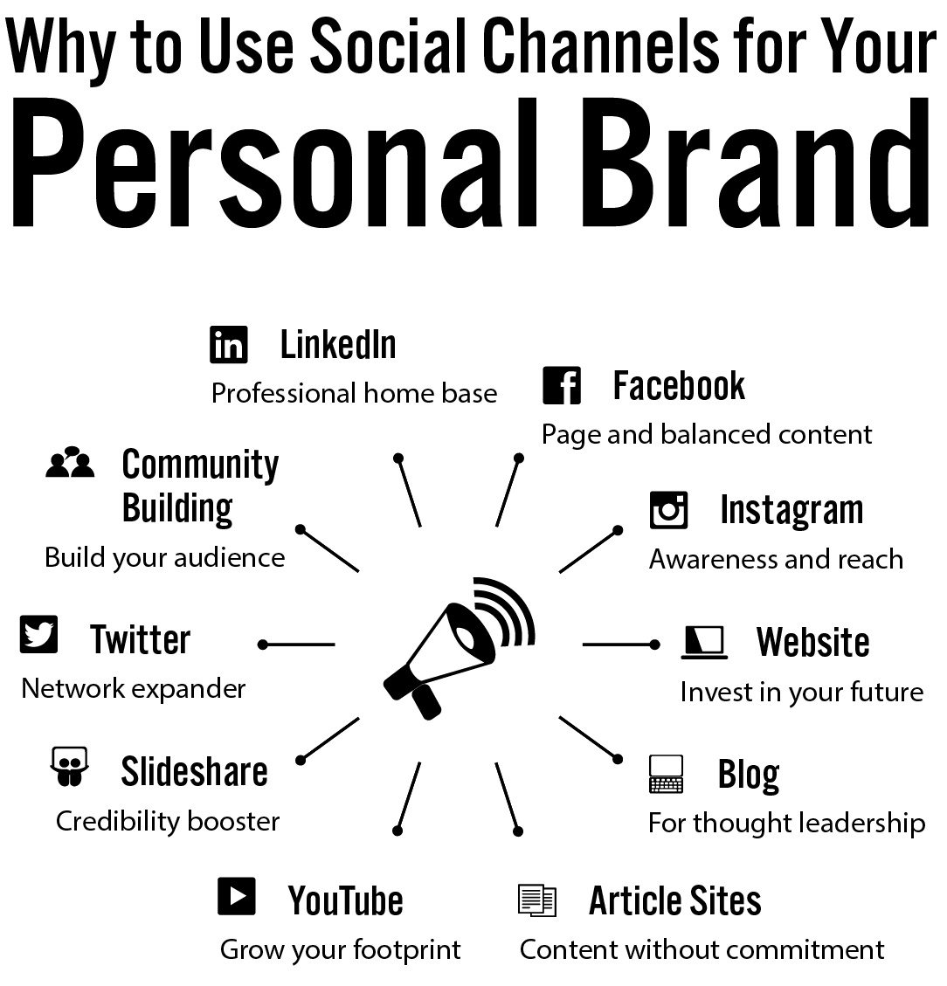
As you evaluate how each social network can fit in to your personal brand delivery, the chart below helps you prioritize social networks based on what most professionals use to gain visibility for their brand online. You may have specific needs that are different from this, but this should be a guide to help you prioritize.

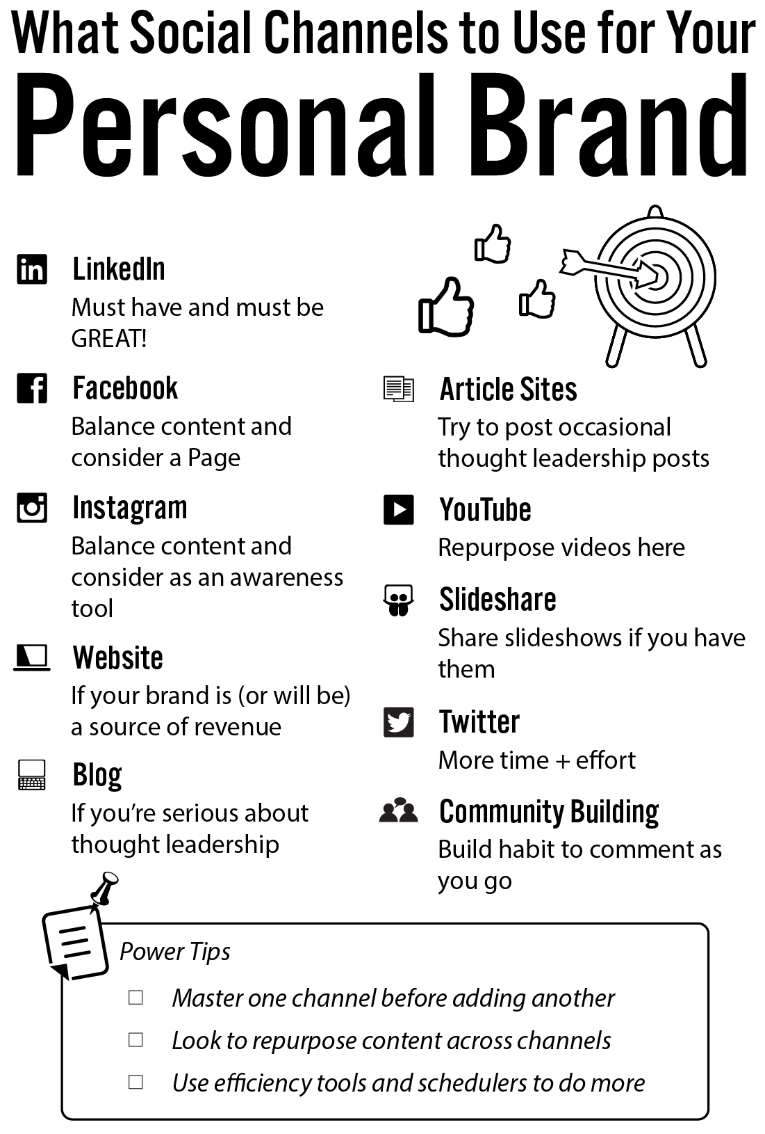
What social networks will you build your platform on (in order of priority) and your primary use for each platform:
Keep in mind that you shouldn’t plan to do everything – especially not immediately. Master one network before moving on to the next and seek to build the habit in participating and posting content regularly.

Example: LinkedIn
Main use: Online profile, expand network and build visibility in my industry with content.
Example: Slideshare
Main use: Post presentations I give at industry events to get more visibility.

1.
Main use:

2.

Main use:

3.

Main use:

4.

Main use:

5.

Main use:

6.

Main use:

7.

Main use:

Social Network Plan
Network:
Objective: What is your primary objective for the network?

Profile: What do you need to do to create an outstanding profile?

People: What is your action plan to grow your audience?

Goal:

Post: How often will you post and what kind of content will you post?

Goal:

Participate: How often will you participate and what are your goals?

Goal:

Evaluate and Optimize: How often will you look at your results and revise your plan?

Summary + Checklist

_____ times a week and accomplish ______________________________________, __________________________________, _________________________________.

Social Network Plan
Example
SAMPLE based on improving an existing LinkedIn profile.
Network: LinkedIn
Objective: What is your primary objective for the network?
Establish credibility, strengthen relationships, grow visibility in the industry, position myself as a thought-leader.

Profile: What do you need to do to create an outstanding profile?
- Update summary and descriptions
- Add relevant media
- Use keywords in content to optimize for search

People: What is your action plan to grow your audience?
- Add 10+ people from “people you may know”
- Add people who participate in targeted industry groups
- Search # from recent conference and add people who attended
- Add people in my industry associations

Goal: 10 new connections per week (invite 20 people per week)

Post: How often will you post and what kind of content will you post?
- 2 posts a week minimum
- 1 video per week

Goal: Reach 100 people/week with content and 5 interactions per post

Participate: How often will you participate and what are your goals?
- Comment on 5 posts/week
- Like 5 posts/week
- 3 Group discussions/week

Goal: 13 quality interactions per week (half with high-value contacts)

Evaluate and Optimize: How often will you look at your results and revise your plan?
- Evaluate content monthly for ideas + improvement

Summary + Checklist

__3__ times a week and accomplish _add 10 new contacts___________________,
reach 100 people with 5 interactions per post_, 13 quality interactions________

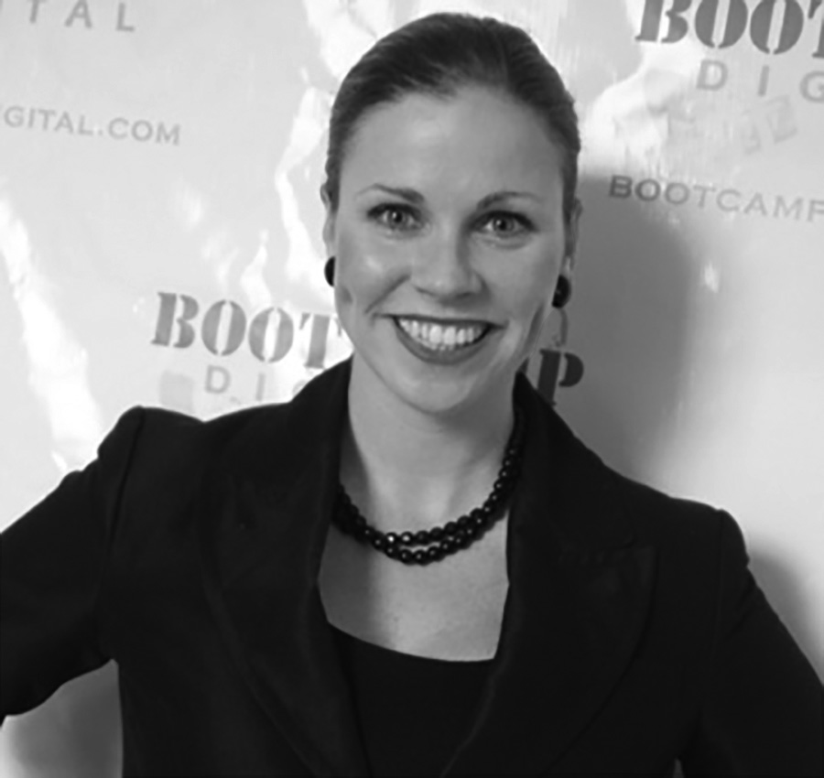
Krista Neher is the CEO of Boot Camp Digital, a bestselling author of six books, international speaker and recognized digital marketing expert with over 15 years of experience in this ever-changing industry.

She has worked with leading companies like Google, P&G, General Mills, Nike, GE, The United States Senate, Prudential, Remax and more. She has also been a featured expert in the Wall Street Journal, The New York Times, CNN, Associated Press, Wired Magazine and CBS News.

Krista is passionate about social media and created one of the first accredited social media certification programs in the world.

Connect with Krista Online:

Krista.Neher.Pro
@KristaNeher
Krista Neher
@KristaNeher

Want to Work with Krista?

Krista works with a wide variety of businesses across industries and can work with you in a number of ways:

• Keynote presentations • 1:1 Coaching
• Workshops • Executive training
• Breakout sessions • Corporate training
• Strategic planning • Customized internal training
programs

Contact Krista for speaking, training, consulting, seminar or workshops: info@bootcampdigital.com or 513-223-3878.

Want to take your social media and digital marketing skills to the next level? Go to www.BootCampDigital.com to see how we can help you succeed
What We Offer at Boot Camp Digital

- Online training courses from Beginner to Advanced
- Industry-recognized Certifications in Social Media, Digital Marketing, Content, SEO, and more
- Live workshops around the U.S.
- Customized corporate team training
- Digital Marketing and Social Media consulting
- 1:1 Coaching and Strategic Planning
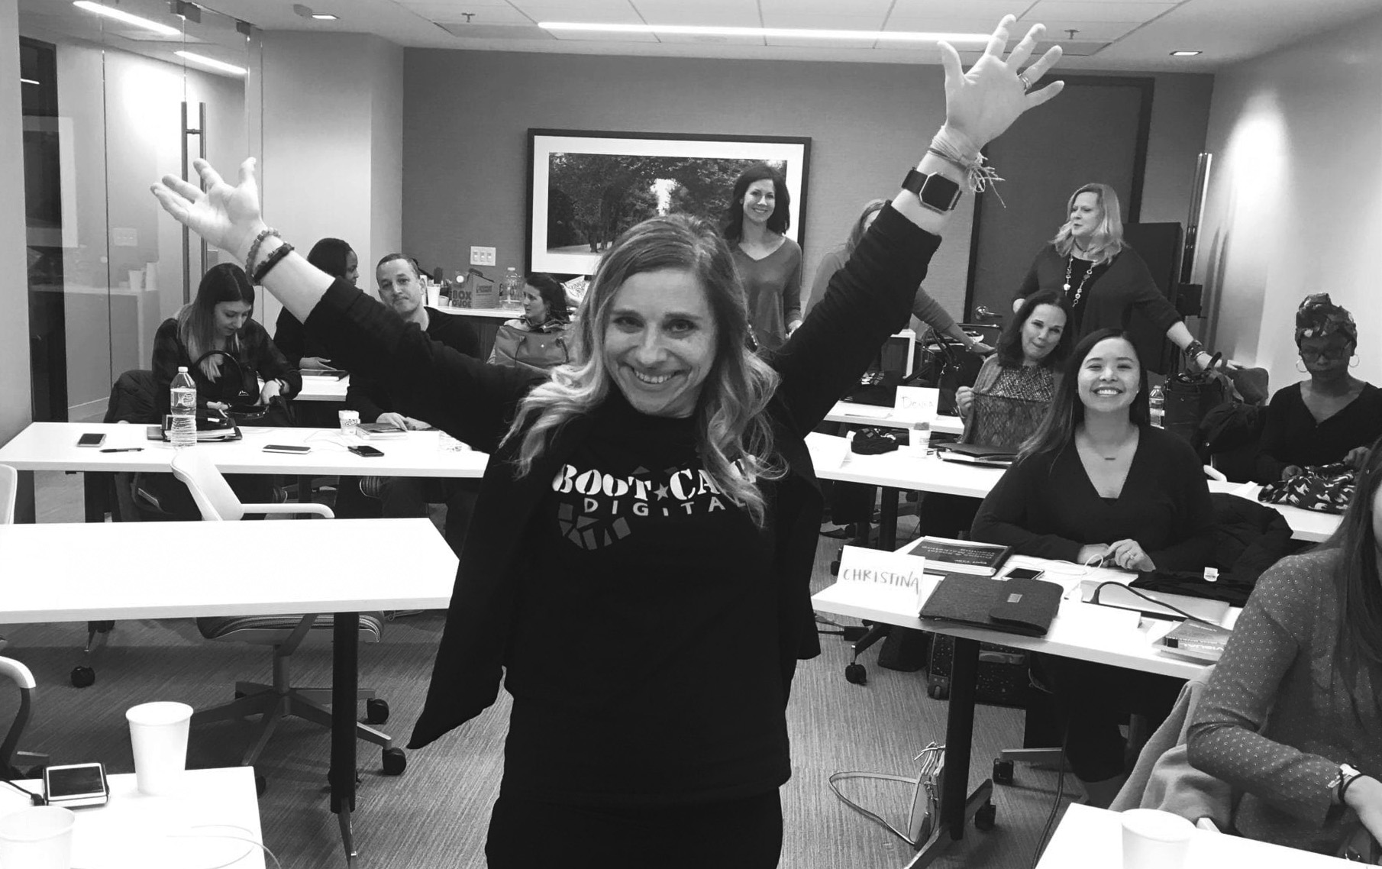

Connect with Us Online

BootCampDigital
@BootCampDigital
@BootCampDigital
Boot Camp Digital

Contact us for speaking, training, consulting, seminar or workshop opportunities at: info@bootcampdigital.com or call us at 513-223-3878.

