What’s Inside the Guide:

This search engine optimization (SEO) action planner will help you to create a clear and effective SEO strategy for your business or organization. The guide follows the process for building a strong SEO strategy as a foundation for your marketing strategy. In the guide, you’ll find:

What’s Inside the Guide: 2
Steps to Building an SEO Strategy 3
Step 1: Research 4
Step 2: Defining Your Strategy 4
Step 3: On-page SEO 5
Step 4: Off-page SEO 6
Step 5: Measure & Improve 6
Prioritizing Your Efforts 7

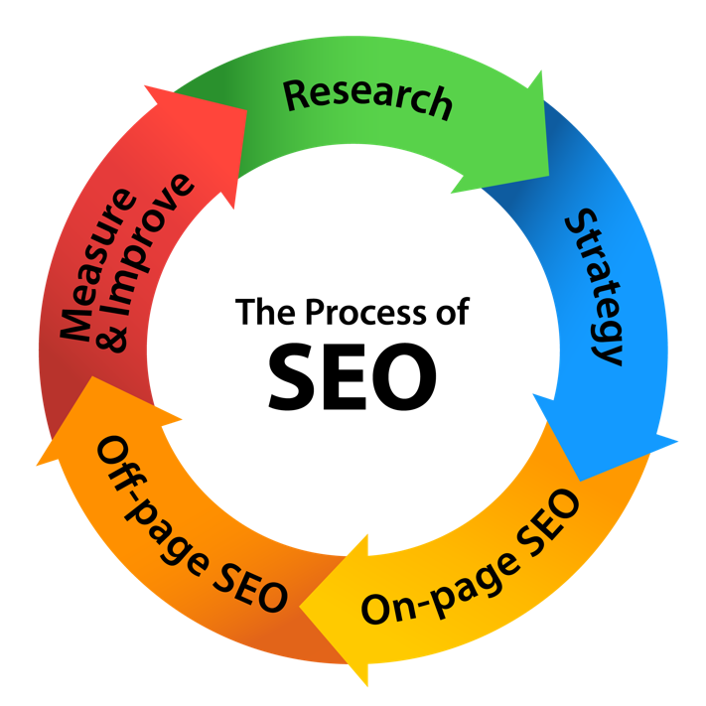
Steps to Building an SEO Strategy

Building an SEO strategy involves five clear steps.
- Research
- Strategy
- On-page SEO
- Off-page SEO
- Measure & Improve
This action planner will guide you through building a strategic SEO plan based on these five steps. At the end of this action planner you will have a clear SEO strategy for your business.
That being said, it is important to keep your strategy and approach agile to adapt to changes in the search engines, your customers, and to integrate learnings that you have discovered along the way. For this reason, we recommend revisiting your strategy quarterly or semi-annually to re-think your strategy and adjust as appropriate.
Step 1: Research
The first step is to listen and assess the landscape. There is more digital data freely available online than more people realize. Listening allows you to learn about your customers, competitors, your business and the category or industry.
A strong digital strategy starts with a clear understanding of what is already happening.
Research your Industry + Audience, Competition, and Keywords:
Research Tools:
• Google Search Results
• Google Trends
• Google Keyword Tool
• Social Networks: Twitter, Pinterest, Instagram, Blogs, Niche Sites
• Community Sites (based on your category)
What are your consumers talking about?
What topics related to what you do are trending?
What needs and interests does your audience have related to your product or industry?

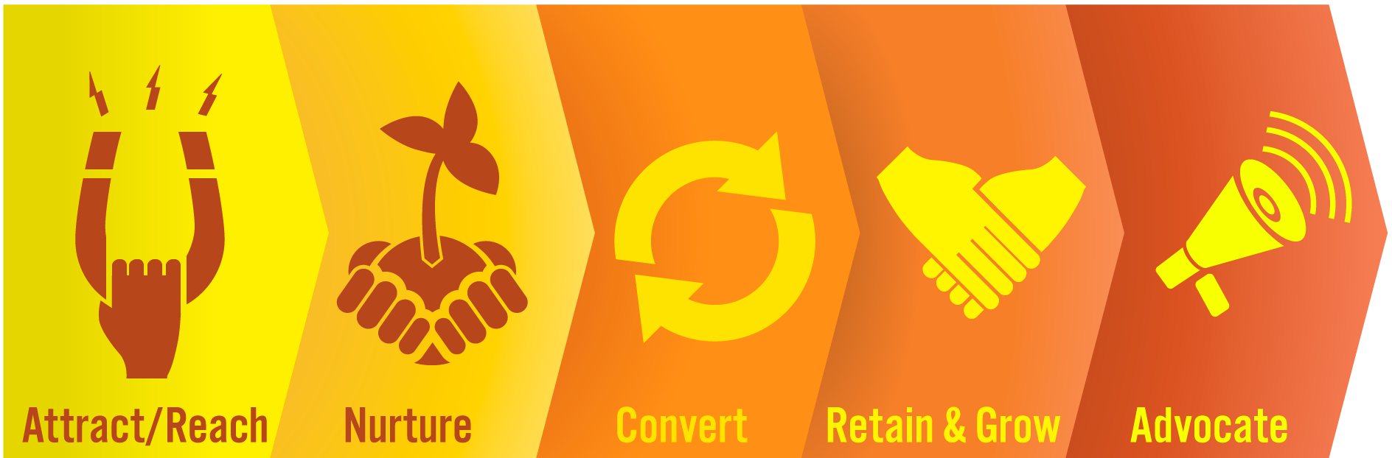
Step 2: Defining Your Strategy
Define Your Goal
Start by defining your goals – on a high level, what do you want to achieve from your SEO efforts? NOTE: Brainstorm a list of possible goals and choose one as your primary focus.
Define Your Strategies
You may choose to focus on one or more areas of the path to purchase (ANCRA). SEO can impact all of these five steps. Start by brainstorming strategies for each step and circle your top 2 – 4 strategies that you want to focus your efforts around.

Attract/Reach –
Nurture –
Convert –
Retain & Grow –
Advocate –

Step 3: On-page SEO

Your content strategy should be based on both your business objectives as well as what your audience is actually interested in. Your website needs to include the keywords and content about the topics that you want to rank for. Matching up content that achieves all of these is often the key to success in SEO.

What keywords will you optimize for?

What problem do you solve for your target audience?

What is your USP (unique selling proposition)?

Step 4: Off-page SEO

The links your website earns from other websites is a signal to search engines that your site is an authority on a topic. The more you have quality, inbound links from relevant, authority level websites, the better your search rankings will be for keywords related to that topic.

Identify your existing linkable assets that you will target for inbound links from other websites. Then, identify link opportunities that you will build on over time to build authority.

What linkable assets do you have?

What link opportunities are the best fit for your business?

Step 5: Measure & Improve

Optimization is all about measuring and improving your results. Determine your objectives, the measurable steps that you will take to achieve your goal, based on the 2-4 strategies that you have chosen to focus on in your plan above. Then, align this to the tactics you will work on to achieve the objectives, and the KPIs you will measure to know if it’s working.

Strategy #1 | Objective #1 | Tactic #1 | KPI:
 |  | Tactic #2 | KPI:
 |  | Tactic #3 | KPI:
 |  | Tactic #4 | KPI:
 | Objective #2 | Tactic #1 | KPI:
 |  | Tactic #2 | KPI:
 |  | Tactic #3 | KPI:
 |  | Tactic #4 | KPI:
 | Objective #3 | Tactic #1 | KPI:
 |  | Tactic #2 | KPI:
 |  | Tactic #3 | KPI:
 |  | Tactic #4 | KPI:
Strategy #2 | Objective #1 | Tactic #1 | KPI:
 |  | Tactic #2 | KPI:
 |  | Tactic #3 | KPI:
 |  | Tactic #4 | KPI:
 | Objective #2 | Tactic #1 | KPI:
 |  | Tactic #2 | KPI:
 |  | Tactic #3 | KPI:
 |  | Tactic #4 | KPI:
 | Objective #3 | Tactic #1 | KPI:
 |  | Tactic #2 | KPI:
 |  | Tactic #3 | KPI:
 |  | Tactic #4 | KPI:

Strategy #3 | Objective #1 | Tactic #1 | KPI:
 |  | Tactic #2 | KPI:
 |  | Tactic #3 | KPI:
 |  | Tactic #4 | KPI:
 | Objective #2 | Tactic #1 | KPI:
 |  | Tactic #2 | KPI:
 |  | Tactic #3 | KPI:
 |  | Tactic #4 | KPI:
 | Objective #3 | Tactic #1 | KPI:
 |  | Tactic #2 | KPI:
 |  | Tactic #3 | KPI:
 |  | Tactic #4 | KPI:

Strategy #4 | Objective #1 | Tactic #1 | KPI:
 |  | Tactic #2 | KPI:
 |  | Tactic #3 | KPI:
 |  | Tactic #4 | KPI:
 | Objective #2 | Tactic #1 | KPI:
 |  | Tactic #2 | KPI:
 |  | Tactic #3 | KPI:
 |  | Tactic #4 | KPI:
 | Objective #3 | Tactic #1 | KPI:
 |  | Tactic #2 | KPI:
 |  | Tactic #3 | KPI:
 |  | Tactic #4 | KPI:

Prioritizing Your Efforts

There is almost no end to the digital marketing tactics that you can use to meet your strategic objectives. That being said, we all have limited time and resources. You probably have an SEO plan with more than you can accomplish immediately.

Prioritize your efforts by plotting them on the Investment and Impact graph to decide where you should focus your efforts. Once you’ve done this, categorize your efforts into immediate, short-term and long-term. Remember it is better to do a few things well vs. many things poorly.
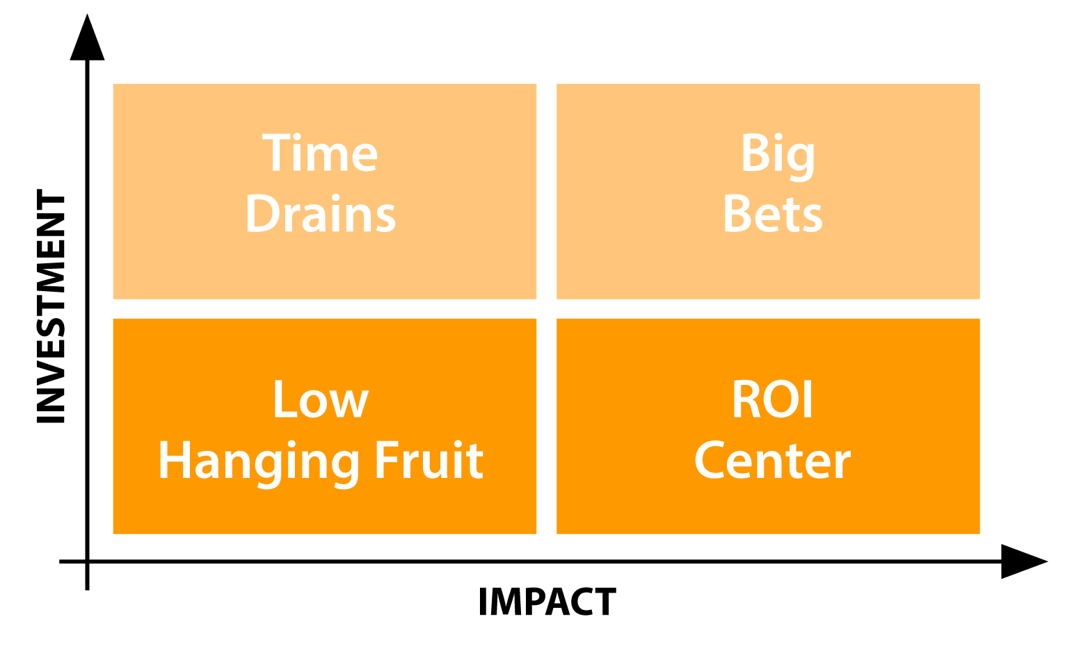

Immediate Implementation

Short-Term

Long-Term

