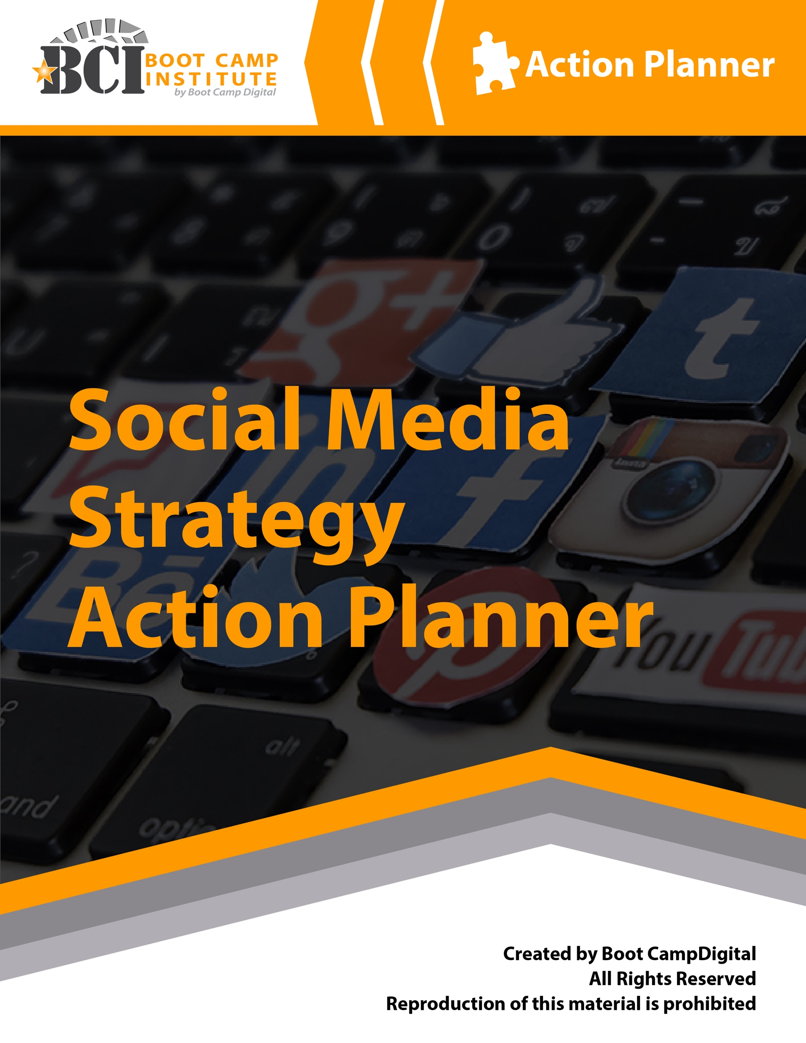

# What’s Inside the Guide:

This social media marketing action planner will help you to create a clear and effective social media strategy for your business or organization. The guide follows the process for building a strong social media strategy. In the guide, you’ll find:

What’s Inside the Guide: 2

Steps to Building a Social Media Strategy 3

Step 1: Listen and Assess the Landscape 4

Listen to Consumers, Competitors and Your Industry: 4

Step 2: Defining Your Strategy 5

Define Your Goal 5

Define Your Strategies 5

Social Media Marketing Objectives 6

Step 3: Identify Your Target Audience 7

Step 4: Define Your Content 8

Facebook Strategy 9

Instagram Strategy 10

LinkedIn Strategy 11

Twitter Strategy 12

Blogging Strategy 13

Pinterest Strategy 14

Prioritizing Your Efforts 15

# Steps to Building a Social Media Strategy

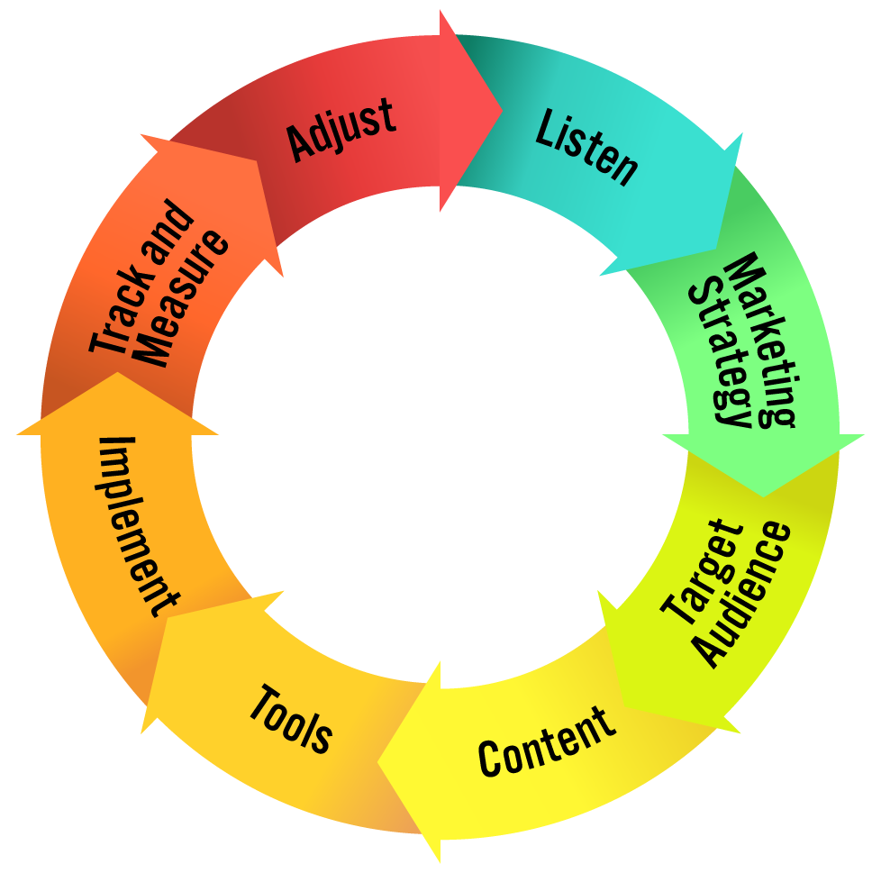

Building a social media marketing strategy involves 8 clear steps.  
  
 **1. Listen and assess the landscape  
 2. Clearly define your strategies  
 3. Understand your target audience  
 4. Define your content  
 5. Choose the tools & tactics to best meet your needs  
 6. Implement with excellence and best practices  
 7. Track & measure  
 8. Adjust & optimize**

This action planner will guide you through building a strategic social media marketing plan based on these eight steps. At the end of this action planner you will have a clear social media marketing strategy for your business.  
  
That being said, it is important to keep your strategy and approach agile to adapt to changes in social media marketing, your customers, and to integrate learnings that you have discovered along the way. For this reason, we recommend **revisiting your strategy quarterly or semi-annually** to re-think your strategy and adjust as appropriate.  
  
This guide will help you to create a strategic social media marketing plan that maps out how to approach social media strategically and have a clear channel strategy for each channel that you use.  
  
  
  
  
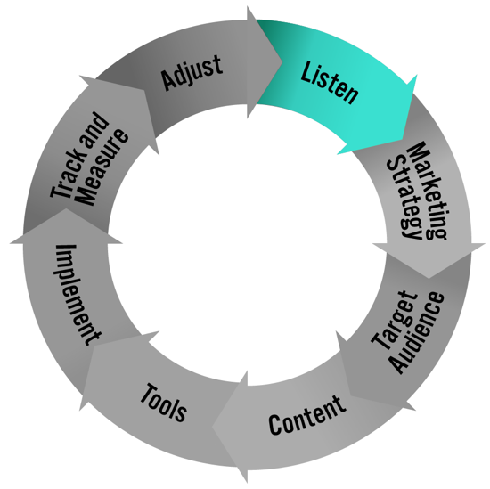Step 1: Listen and Assess the Landscape  
The first step is to listen and assess the landscape. There is more digital data freely available online than more people realize. Listening allows you to learn about your customers, competitors, your business and the category or industry.  
  
A strong digital strategy starts with a clear understanding of what is already happening.   
  
**Listen to Consumers, Competitors and Your Industry:**Where to Listen:  
 • Google Search Results  
 • Google Trends  
 • Google Keyword Tool  
 • Social Networks: Twitter, Pinterest, Instagram, Blogs, Niche Sites  
 • Community Sites (based on your category) **Where are your consumers online?  
  
  
What are they talking about?  
  
  
What topics related to what you do are trending?**

**What needs and interests do they have related to your product or industry?**

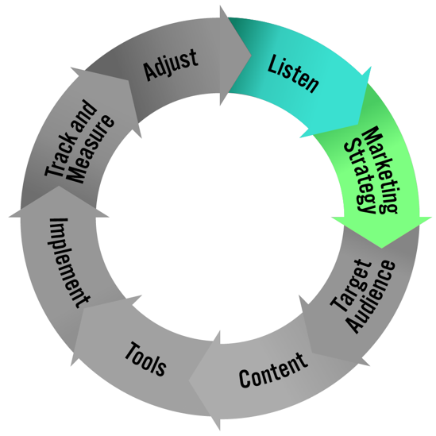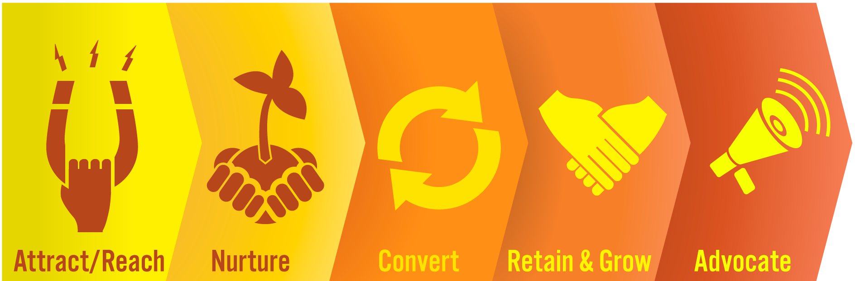Step 2: Defining Your Strategy  
**Define Your Goal**  
Start by defining your goals – on a high level, what do you want to achieve from your efforts in digital marketing? NOTE: Brainstorm a list of possible goals and choose one as your primary focus.  
  
**Define Your Strategies**  
You may choose to focus on one or more areas of the path to purchase. Digital marketing can impact all of these 5 steps. Start by brainstorming strategies for each step and circle your top 2 – 4 strategies that you want to focus your efforts around.

**Attract/Reach**

**Nurture**  
  
**Convert**  
  
**Retain & Grow**

**Advocate**  
Social Media Marketing Objectives  
Rank your objectives (use 0 for objectives that are not important at all)

* Build positive brand equity for your organization
* Position yourself/your organization as an expert
* Acquire new customers/Lead generation
* Build awareness for your business or your brand
* Provide updates on company news/events
* Build relationships and community with current customers
* Search Engine Optimization2
* Get feedback from current and potential customers
* Develop relationships with thought leaders/influencers in your space3
* Highlight talented individuals in your organization
* Humanize your organization/give a personal “face” to the organization
* Market Research
* Focus groups
* Humanize your brand
* Word of mouth
* Increase customer loyalty
* Customer service
* New product ideas
* Drive sales
* Promote New Products
* Other_________________
* Other_________________
* Other_________________

**Community building** is a field of practices directed toward the creation or enhancement of [community](http://en.wikipedia.org/wiki/Community) between [individuals](http://en.wikipedia.org/wiki/Individual) with a common interest. For an organization this may mean building a community of people who are passionate about your organization (ie. Starbuck’s Enthusiasts) or a passion area related to your company (ie. Kashi and Healthy Living, Canon and Photography).

2 **Search Engine Optimization** (**SEO**) is the process of improving the volume and quality of traffic to a [web site](http://en.wikipedia.org/wiki/Web_site) from [search engines](http://en.wikipedia.org/wiki/Search_engine) via "natural" ("organic" or "algorithmic") [search results](http://en.wikipedia.org/wiki/Search_engine_results_page). Usually, the earlier a site is presented in the search results, or the higher it "ranks," the more searchers will visit that site. As more and more consumers search for information online this is a growing area of importance for many businesses.

3 **Thought Leaders/Influencers** for your industry are those leading the trends in the industry; those who others in your space or industry look to for advice. A blog can be an excellent entry-point to develop relationships.

# Step 3: Identify Your Target Audience

Clearly identifying your target audience is important since digital marketing allows us to reach audiences much more specific than what is possible in traditional marketing.

It is important to go beyond demographics when identifying your audience and start thinking about who they really are and why they use your product.

**../../Design%20Files%20BCD/Presentation%20Graphics/TargetAudienceSoap.ai**As you look to execute in digital marketing the better you’ve identified your target the easier it will be to execute.

NOTE: You may have multiple target audiences that you want to reach, which is fine.

**Who is your target audience demographically?**

**What problem do you solve for them?**

**What are they interested in?**

**How do they behave online and offline?**

# Step 4: Define Your Content

Your content strategy should be based on both your business objectives as well as what your audience is actually interested in. Matching up content that achieves both of these is often the key to success in digital marketing.

With an increase in competitiveness for online attention, great (not just good) content is vital to your success.

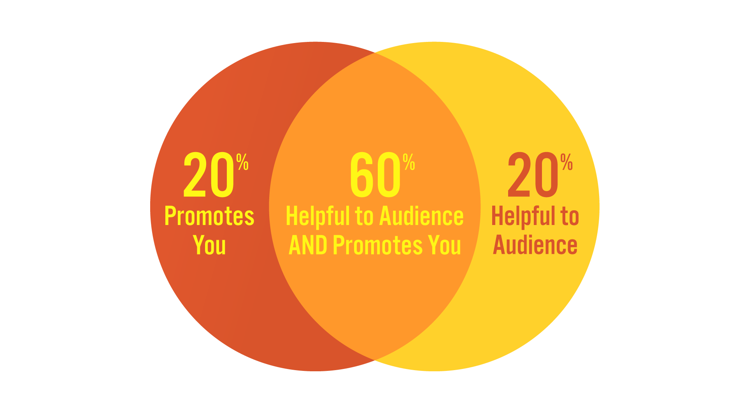

**What content is relevant to your business strategies?**

**What content does your customers/target audience care about?**

**Define 4 – 10 content “buckets” or topics that you think are relevant for social media. Each social media channel may have more specific content as well.**

# Steps 5-8: Tools, Implementation, Track & Measure, Adjust Facebook Strategy

**Strategy**

|  |  |
| --- | --- |
| Objective (s): |  |
| Target Audience |  |
| Content Strategy  (Buckets) |  |
| Pages/Accounts to watch or interact with |  |

**Implementation Details**

|  |  |
| --- | --- |
| Audience building plan: |  |
| Post frequency: |  |
| Media types/frequency: |  |
| Boosting/paid strategy: |  |
| Interaction and management plan: |  |
| KPIS to measure success |  |

# Instagram Strategy

**Strategy**

|  |  |
| --- | --- |
| Objective (s): |  |
| Target Audience |  |
| Content Strategy  (Buckets) |  |
| Pages/Accounts to watch or interact with |  |

**Implementation Details**

|  |  |
| --- | --- |
| Audience building plan: |  |
| Post frequency: |  |
| Media types/frequency: |  |
| Boosting/paid strategy: |  |
| Interaction and management plan: |  |
| KPIs to measure success |  |

# LinkedIn Strategy

**Strategy**

|  |  |
| --- | --- |
| Objective (s): |  |
| Target Audience |  |
| Content Strategy  (Buckets) |  |
| Pages/Accounts to watch or interact with |  |

**Implementation Details**

|  |  |
| --- | --- |
| Audience building plan: |  |
| Post frequency: |  |
| Media types/frequency: |  |
| Boosting/paid strategy: |  |
| Interaction and management plan: |  |
| KPIs to measure success |  |

# Twitter Strategy

**Strategy**

|  |  |
| --- | --- |
| Objective (s): |  |
| Target Audience |  |
| Content Strategy  (Buckets) |  |
| Pages/Accounts to watch or interact with |  |

**Implementation Details**

|  |  |
| --- | --- |
| Audience building plan: |  |
| Post frequency: |  |
| Media types/frequency: |  |
| Boosting/paid strategy: |  |
| Interaction and management plan: |  |
| KPIs to measure success |  |

# Blogging Strategy

**Strategy**

|  |  |
| --- | --- |
| Objective (s): |  |
| Target Audience |  |
| Content Strategy  (Buckets) |  |
| Pages/Accounts to watch or interact with |  |

**Implementation Details**

|  |  |
| --- | --- |
| Audience building plan: |  |
| Post frequency: |  |
| Media types/frequency: |  |
| Boosting/paid strategy: |  |
| Interaction and management plan: |  |
| KPIs to measure success |  |

# Pinterest Strategy

**Strategy**

|  |  |
| --- | --- |
| Objective (s): |  |
| Target Audience |  |
| Content Strategy  (Buckets) |  |
| Pages/Accounts to watch or interact with |  |

**Implementation Details**

|  |  |
| --- | --- |
| Audience building plan: |  |
| Post frequency: |  |
| Media types/frequency: |  |
| Boosting/paid strategy: |  |
| Interaction and management plan: |  |
| KPIs to measure success |  |

# Prioritizing Your Efforts

There is almost no end to the digital marketing tactics that you can use to meet your strategic objectives. That being said, we all have limited time and resources. You probably have a social media plan with more than you can accomplish immediately.

Prioritize your efforts by plotting them on the Investment and Impact graph to decide where you should focus your efforts. Once you’ve done this, categorize your efforts into immediate, short-term and long-term. Remember it is better to do a few things well vs. many things poorly.

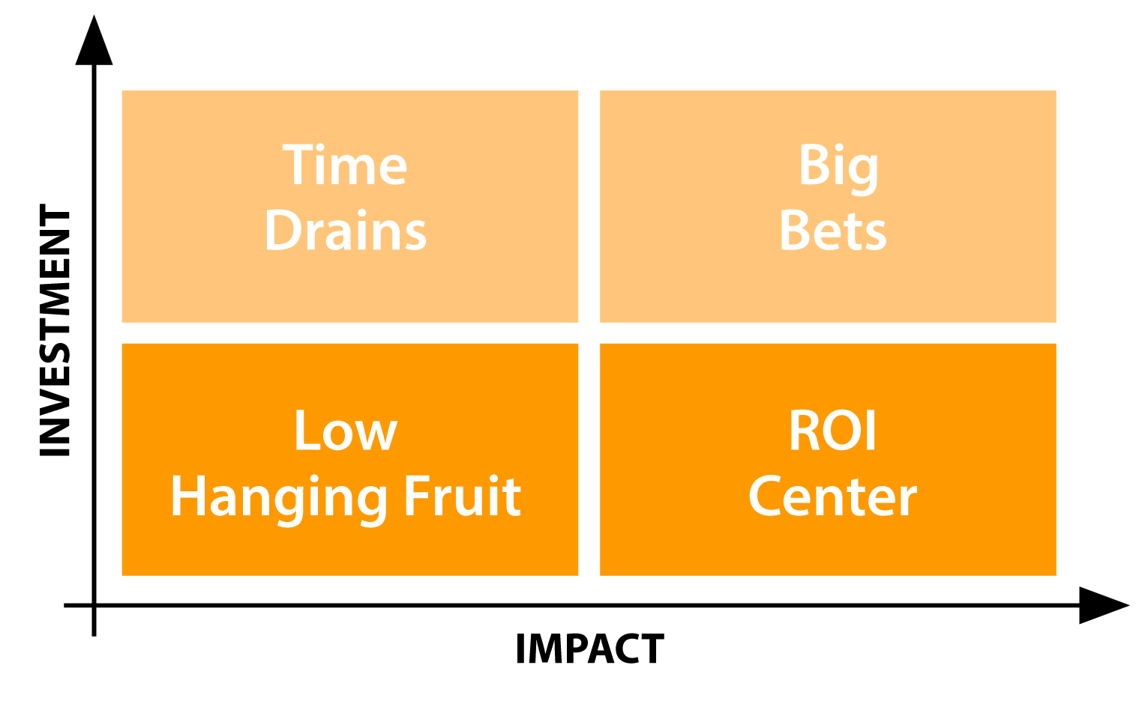

**Immediate Implementation**

**Short-Term**

**Long-Term**