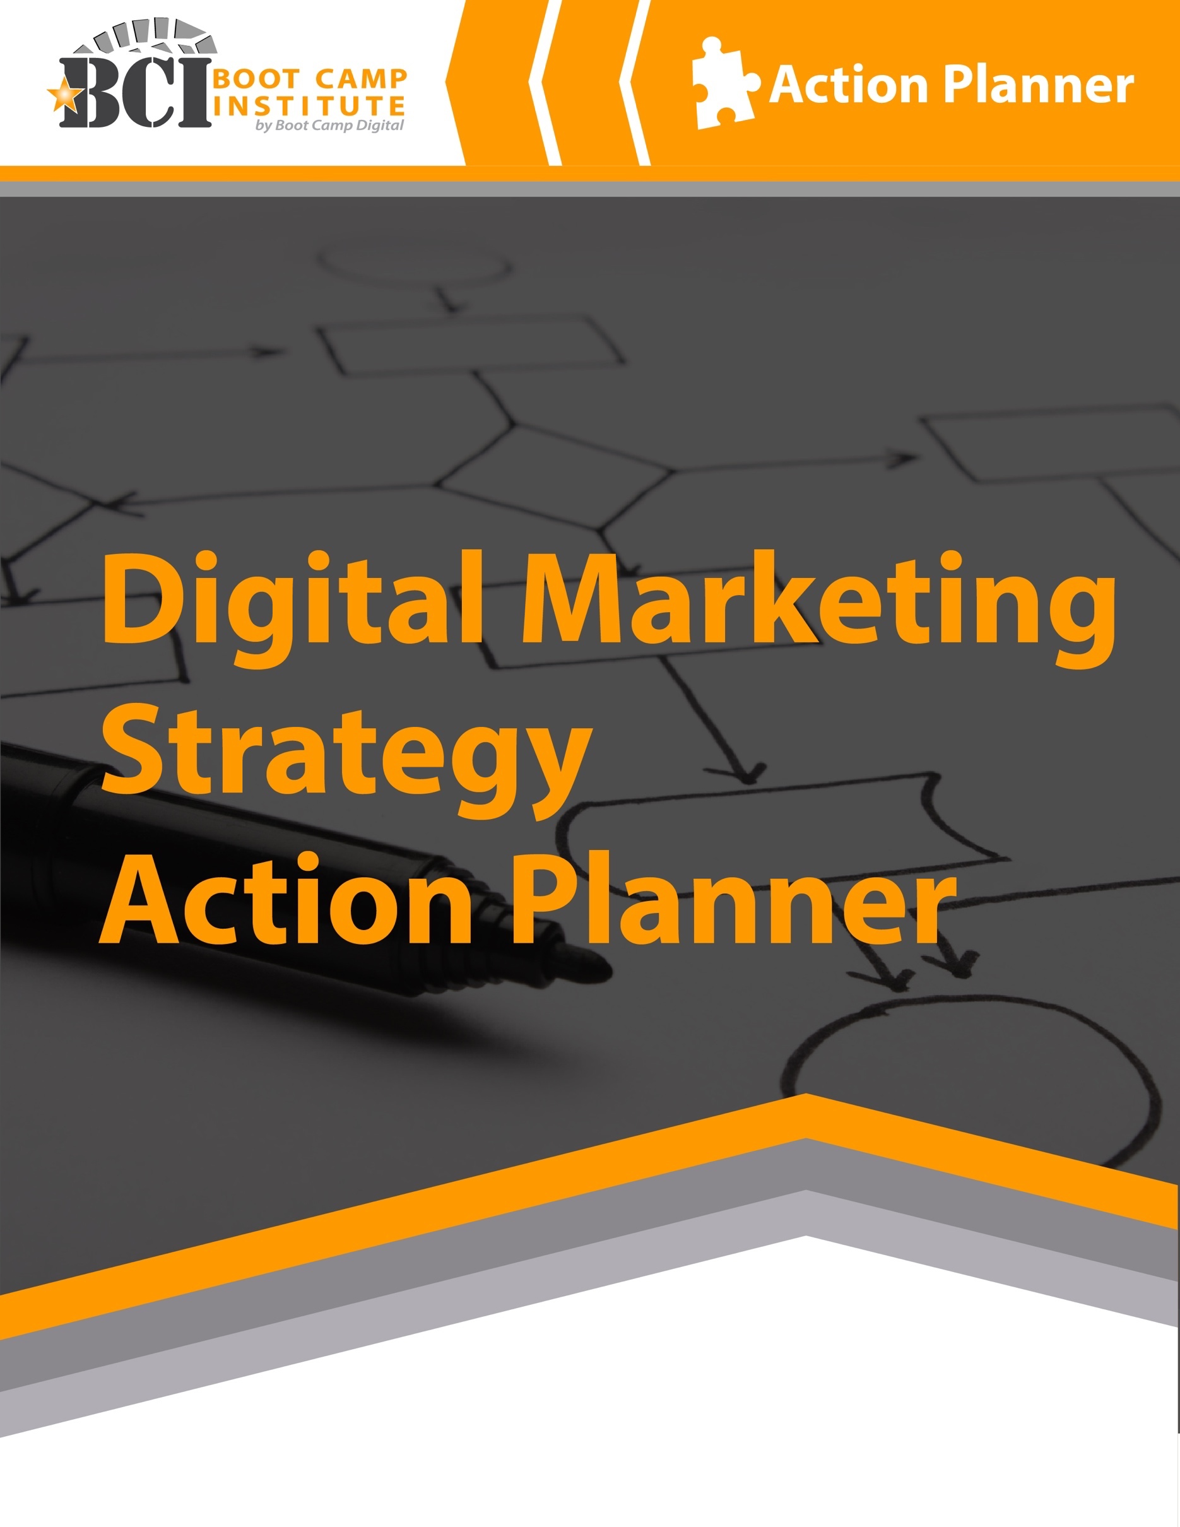
© Boot Camp Digital • Reproduction Prohibited
www.BootCampDigital.com • info@BootCampDigital.com
What’s Inside the Guide:
This Digital Marketing Strategy Action Planner will help you to create a clear and effective digital strategy for your business or organization. To make the most out of this guide, consider the following tips:

- Don’t worry if you don’t have all of the answers. Get as close as you can and move on. Done is better than perfect.
- Prioritize the areas that matter most to your business. Don’t complete sections that aren’t relevant to you. Focus on what will get you results.
- Use a highlighter to highlight the ACTION items separately from your ideas or insights. This will make it easier for you to plan what you want to do.
- Change your plan as needed. Remember that this isn’t set in stone. You can and should learn as you go and adapt. Don’t stick to a plan that isn’t working.
- Think strategy over tactics. While some tactics or tools might be exciting, always link back to how it contributes to your business goals or objectives.
In the guide, you’ll find:
Steps to Building a Digital Marketing Strategy 1
Step 1: Listen and Assess the Landscape 2
Listen for Your Business/Brand/Company: 2
Listen to Competitors: 3
Listen to the Category or Industry: 4
Listen to Consumers: 5
Step 2: Defining Your Strategy: GSOT 6
Define Your Goal 6
Define Your Strategies 7
Define Your Objectives 8
Step 3: Identify Your Target Audience 9
Step 4: Define Your Content 10
Content Topics 10
Content Mediums 12
Tone of Voice 13
Step 5: Define Your Tools and Tactics 14
The Digital Marketing Landscape 14
Social Media 15
Digital Advertising 17
SEO (Search Engine Optimization) 18
Website 19
Conversational Marketing 21
Email 23
CRM 24
Mobile Marketing 25
Step 6: Implement 26
Prioritize Tactics – Hero, Hub, Hygiene 28
Prioritize Tactics – Investment/Impact 29
One Page Digital Marketing Execution Plan 30
Step 7: Measurement 31
Digital Reporting 32
ROI and Value of Investment 32
Step 8: Optimization 33
Build Your Analytics Rhythm 34

Steps to Building a Digital Marketing Strategy
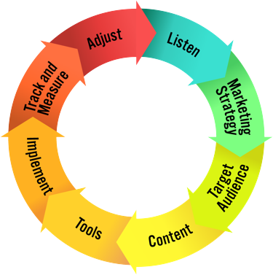
Building a digital marketing strategy involves 8 clear steps:
- Listen and Assess the Landscape
- Clearly Define Your Strategies
- Understand Your Target Audience
- Define Your Content
- Choose the Tools & Tactics to Best Meet Your Needs
- Implement with Excellence and Best Practices
- Track & Measure
- Adjust & Optimize

This Action Planner will guide you through building a strategic digital marketing plan based on these 8 steps. At the end of this action planner you will have a clear digital marketing strategy for your business.
That being said, it is important to keep your strategy and approach agile to adapt to changes in digital marketing, your customers and to integrate learnings that you have along the way. For this reason, we recommend revisiting your digital strategy quarterly or semi-annually to re-think your strategy and adjust as appropriate.
Before you get started, it is helpful to make sure that your digital marketing aligns with the rest of your organization business & marketing strategies. If you have any of the documents below (formally or informally) have them handy as you develop your digital strategy:
- Business plan or strategy
- Marketing plan
- Buyer personas
- Target audience information

Step 1: Listen and Assess the Landscape
The first step is to listen and assess the landscape. There is more digital data freely available online than more people realize. Listening allows you to learn about your customers, competitors, your business and the category or industry.

A strong digital strategy starts with a clear understanding of what is already happening.

Listen for Your Business/Brand/Company:
Where to Listen:

Google Search Results
  - Google Trends
  - Google Keyword Tool
  - Social Networks: Twitter, Pinterest, Instagram, LinkedIn, Facebook, Discussion
Forums, Blogs, Niche Sites
  - Community or Industry Sites (based on your category)
  - Customer service questions/calls/emails

What are people already saying about your business?

What topics are most asked/discussed or mentioned?

Are any of your current executions effectively driving word-of-mouth?

Overall, what is the sentiment about your business that is discussed online?

Listen to Competitors:
Where to Listen:

Search competitors across digital channels
  - Search engine results
  - Google trends
  - Google keyword tool
  - Social media mentions

List your top competitors to evaluate (3-5):

What digital channels do your competitors use? (consider all channels – paid, earned, owned)

What are their strategies?

What do they seem to do right? What strategies are working?

What do they seem to do wrong? Where are they missing out?

Listen to the Category or Industry:
Where to Listen:

Search engine results
- Google trends
- Google keyword tool
- Social media mentions
- Discussion forums
- Blogs
- Niche industry sites
- Industry associations or news sites

What do people say about the category or industry? What questions do they have?

What content are they interested in related to the industry or category? What questions do people have?

What content is popular? Why?

What are people passionate about related to your industry or category?

What are their pain points related to your category or industry?

What media sites, accounts or people do they look to for advice or to have their questions answered?

Listen to Consumers:
Where to Listen:

Google Search Results
  - Social Networks: Twitter, Pinterest, Instagram, LinkedIn, Facebook, Discussion Forums, Blogs, Niche Sites
  - Community or Industry Sites (based on your category)
  - Google Trends

Where are your consumers online? Where are they open to discussions related to your business or industry?

What are they talking about? What topics resonate with them related to your business?

What topics related to what you do are trending?

What needs and interests do they have related to your product or industry?

Who are some of the top influencers that your target audience follows? Who do they look to for advice or insights?

What words and phrases do they use to discuss your category or industry? What tone of voice do they use? What is the sentiment around it?

Step 2: Defining Your Strategy: GSOT
Define your strategy with the GSOT method – Goals, Strategies, Objectives and Tactics. One of the biggest mistakes in digital marketing is starting with tactics and trying to make them fit into a strategy. Start with your goals and strategies to create a strategic digital plan that drives results.

Define Your Goal
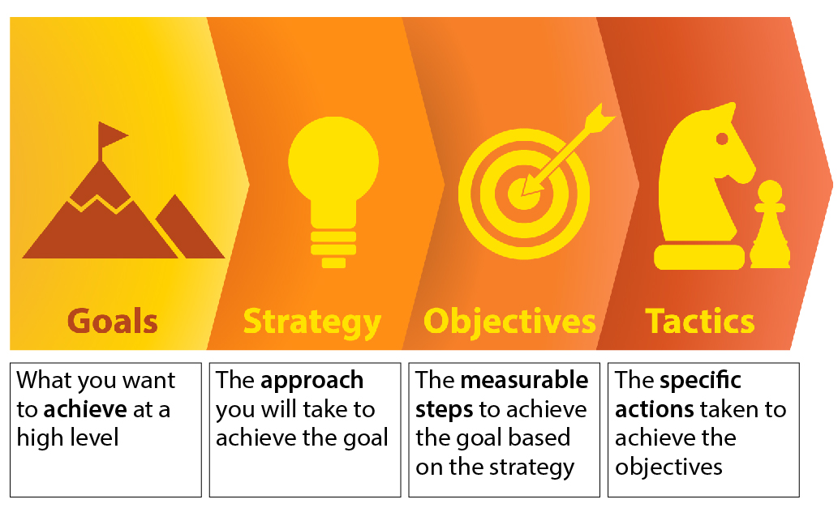
Start by defining your goals – on a high level, what do you want to achieve from your efforts in digital marketing?

NOTE: If needed, brainstorm a list of possible goals and choose one as your primary focus.

Define Your Strategies
You may employ multiple strategies to achieve your goal. Your strategies are the approaches that you use to achieve the goal.
It is helpful to consider your strategies at each stage of the digital path to purchase – ANCRA.

You may choose to focus on one or more areas of the path to purchase. Digital marketing can impact all of these 5 steps.

Start by brainstorming strategies for each step and circle your top 2-4 strategies that you want to focus your efforts around.
Attract/Reach –

Nurture –

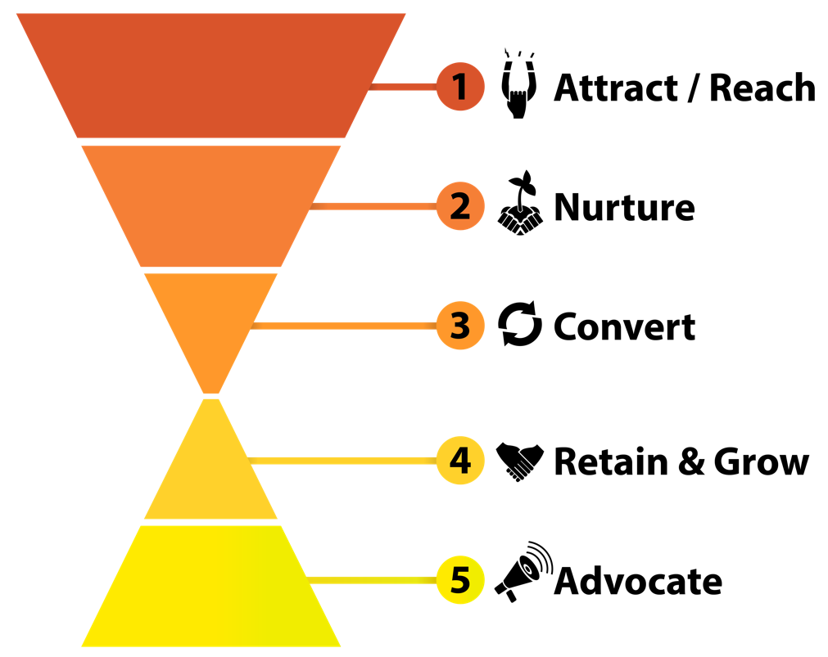

Convert –

Retain + Grow –

Advocate –

Define Your Objectives
Based on the strategies you selected you’ll now want to define your digital marketing objectives. These should be measurable things that you want to achieve as a result of your digital marketing efforts.

Choose approximately 1- 4 objectives for each strategy. Use this space to brainstorm ideas and circle your best ones.

STRATEGY 1 –
Objectives:

STRATEGY 2 –
Objectives:

STRATEGY 3 –
Objectives:

STRATEGY 4 –
Objectives:

NOTE: We will define the tactics at the end of this action planner.

Step 3: Identify Your Target Audience
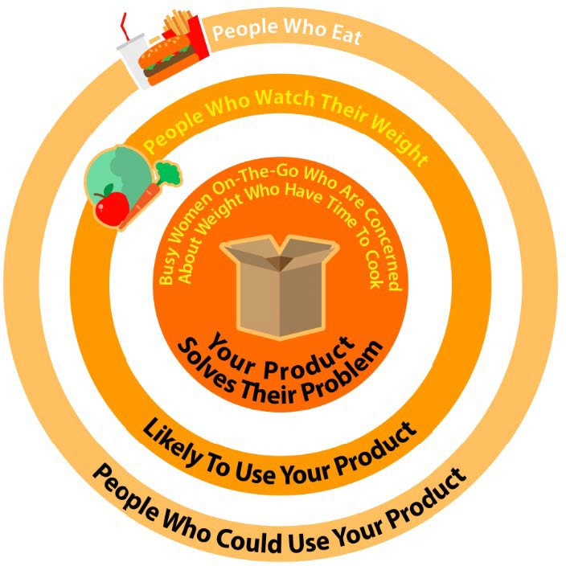
Clearly identifying your target audience is important since digital marketing allows us to reach audiences much more specific than what is possible in traditional marketing.

It is important to go beyond demographics when identifying your audience and start thinking about who they really are and why they use your product.

As you look to execute in digital marketing the better you’ve identified your target the easier it will be to execute.
NOTE: You may have multiple target audiences that you want to reach, which is fine.

Who is your target audience demographically?

What problem do you solve for them?

What are they interested in?

How do they behave online and offline?

Step 4: Define Your Content
Your content strategy should be based on both your business objectives as well as what your audience is actually interested in. Matching up content that achieves both of these is often the key to success in digital marketing.

With an increase in competitiveness for online attention, great (not just good) content is vital to your success. Your content plan should include 3 key items: the topics you will post about, the content formats or mediums you should be prepared to create, and the tone of voice or style guides that are most appropriate for your business or brand. The better you define your content upfront, the easier (and more effective) your digital marketing execution will be.

Content Topics

NOTE: Review your notes from the LISTENING stage to develop your content plan. Consider your target audience, competitors and industry/category in developing an effective plan.

What content is relevant to your business strategies?

What content does your customer/target audience care about?

What content topics overlap the 2 areas? What content is right for your digital strategy?
(Aim for 4-8 content topics). You can even include some sample post titles to get started.

TOPIC 1 –
Sample Post Titles:

TOPIC 2 –
Sample Post Titles:

TOPIC 3 –
Sample Post Titles:

TOPIC 4 –
Sample Post Titles:

TOPIC 5 –
Sample Post Titles:

TOPIC 6 –
Sample Post Titles:

Content Mediums
As you look at your content topics, consider the format that your content will take. Will it be text, image or video? A combination of all 3? While your digital marketing tactics will usually define the specific content formats you will create, some of your content may be best suited to different mediums. Consider how you will use the following mediums as a part of your content strategy:
NOTE: You may need to come back to this section after you determine the digital tools that you will use.
Text –

Images –

Videos –

Tone of Voice
Determine the tone of voice and visual style for all of your digital assets.
Visual Assets to Define:
- Logo
- Logo variants
- Fonts
- Design assets (icon, etc.)
- Colors
- Images to use
What is the distinctive voice of your business?

Is your brand serious or funny? In what way? What is or isn’t appropriate?

What should your brand sound like online? What type of language should be used?

If your brand had a celebrity spokesperson, who would it be?

Step 5: Define Your Tools and Tactics
Each digital marketing tool that you use should have its own plan for specifically how you will use it and what it will achieve. That being said, it is helpful to step back and think strategically about the digital marketing tools at your disposal and how they can help to achieve your goals.

The Digital Marketing Landscape
As a refresher, the image below represents the digital marketing landscape and top tools/tactics used in each area. It is helpful to consider how each area may fit into your strategy.
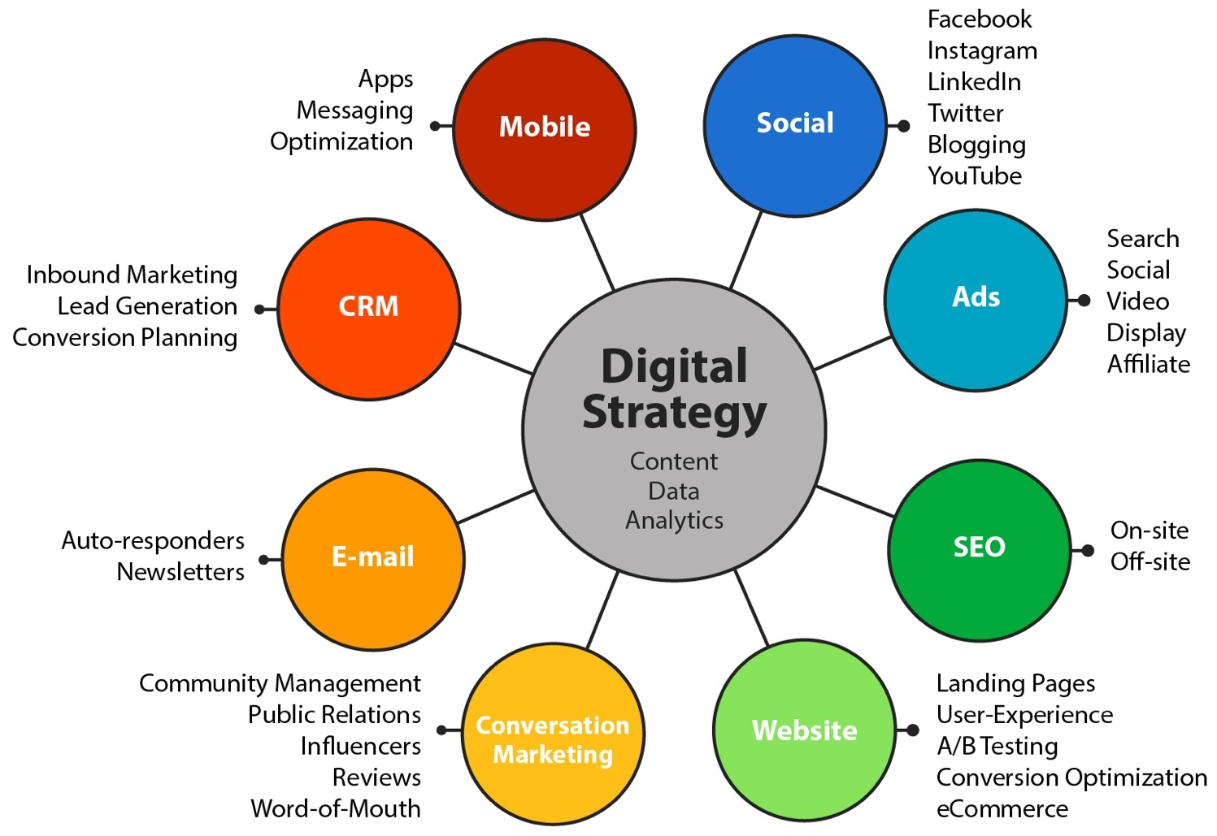

Social Media
How can you use each social network strategically to achieve your digital objectives?
Facebook –

Instagram –

Twitter –

YouTube –

LinkedIn –

Pinterest –

Blogs –

Other –
How will you approach building your presence on social media? The primary approaches are Organic, Paid and Community.

How will you build and grow your presence? Whether you are new to a social network or wanting to make your presence more effective it is helpful to evaluate each of the 4Ps.

NOTE: This may be different for each channel that you participate in, and each channel could have a different mix of the three approaches.
Social Network #1 –
Approach (Organic, Paid, Community):

Plan (Profile, People, Post, Participate):

Social Network #2 –
Approach (Organic, Paid, Community):

Plan (Profile, People, Post, Participate):

Social Network #3 –
Approach (Organic, Paid, Community):

Plan (Profile, People, Post, Participate):

Digital Advertising
How can you use each type of digital ad strategically to achieve your digital objectives?
Search Ads –

Social Ads –

Video Ads –

Display Ads –

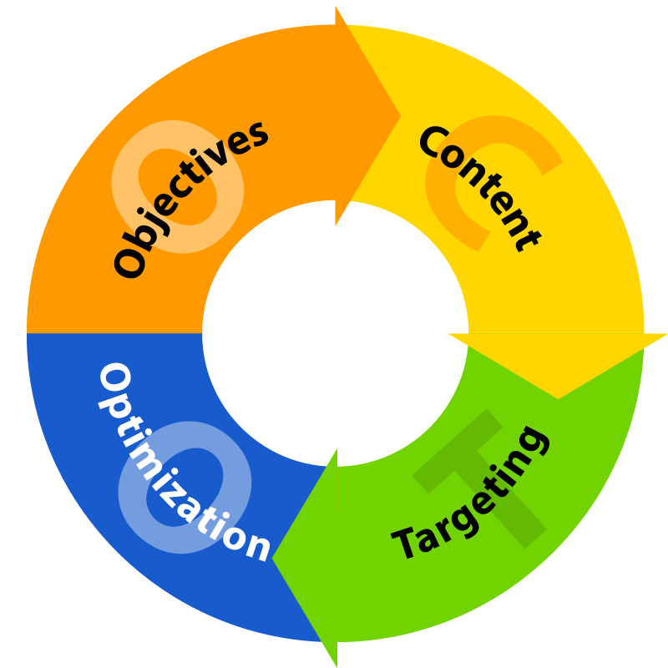
Define your OCTO for the ad platform that is your biggest priority first.
Objective –

Content –

Target –

Optimization Plan – (what and when will you optimize)

SEO (Search Engine Optimization)
What topics, phrases or keywords do you want to rank for in search engines?
Consider brand, category and affinity. Focus on the most relevant first and then expand once you have success. You may have a strategy for your business overall or for individual products or services.
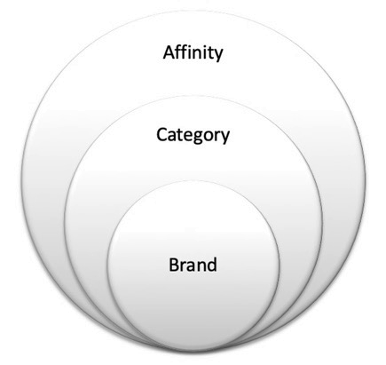
Brand –

Category –

Affinity –
How will you improve your search rankings for these terms?
Authority (links + shares) –
Power Tip:
Check your links via a backlink checker to see how you compare to competition.

Relevance (content) –
Power Tip:
Check which topics or keywords you need to create content around to rank in search.

Technical (site) –
Power Tip:
Go to www.woorank.com for technical errors and check the Google Search Console.

Website
How does your site currently perform?
Power Tip:
Look at your Google Analytics to understand your current site performance over time.

Site Speed (GTMetrix.com) –
Mobile Friendly (Google Mobile Friendly Test –

Clean and Simple Design?

Content?

Call to Action or Conversions?

Usability or Ease of Use?

What is your website strategy?
Rank in priority order the top 5 things that you want your website to achieve for your business.

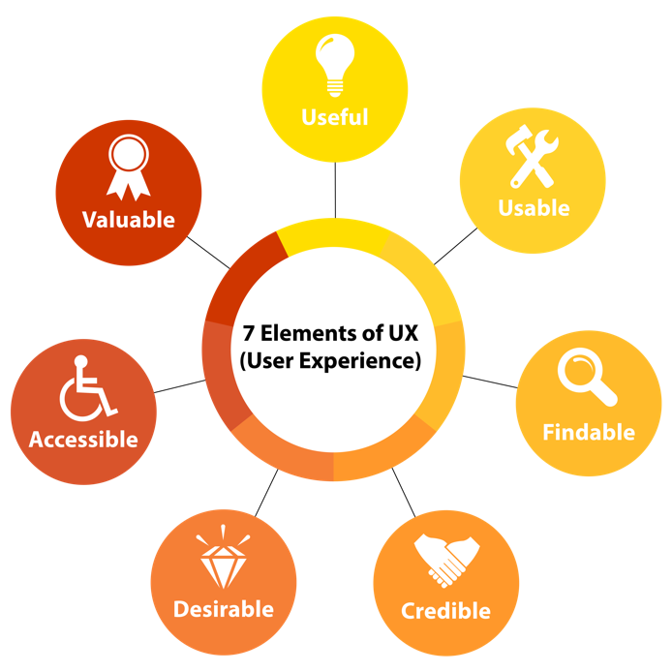
How can you improve your website?
Content:
What content is missing? What should be improved? Does this match your SEO strategy for content? Do you need to change/improve your site structure?

Design:
What do you need to improve in the design areas of your site?

Technical:
Do you need to change any aspects to the technical setup of your site?

Conversational Marketing
How can you use each of the following as a part of your digital marketing execution?
Influencer Marketing
Power Tip:
Consider formal and informal approaches to working with industry influencers.

Ratings and Reviews
Power Tip:
Google and Facebook reviews are a great starting point for EVERY business.

Community Management
Power Tip:
Have a plan to respond to comments and questions quickly on social.

Online PR
Power Tip:
Bloggers and online publications can be easy ways to generate PR.

Online Word of Mouth
Power Tip:
Find simple ways to get people talking, or create a specific execution.

Employee Advocacy
Power Tip:
Employees can easily help spread your message if you inspire them ;-)

Email
How can email help to achieve your marketing objectives?

How can you collect email addresses?
Power Tip:
Conduct a touchpoint analysis. Define the value proposition for people to give their email.

How can you drive opens of your emails?
Power Tip:
Remember CURVE: Curiosity, Urgency, Relevancy, Value and Emotion

What ACTION do you want people to take after reading your email?
Power Tip:
EVERY email you send should have a single clear purpose that drives action.

What content will you include in your emails?
Power Tip:
If you are new to email experiment with content and see what resonates.

How often will you send them?

How often will you analyze your email analytics?

CRM
How can a CRM help to achieve your marketing objectives?
Power Tip:
Do you have contact information for customers or prospects? Do you need to manage leads? Do you want to be more targeted? If you answer YES to any of these,
you may consider a CRM.

How could you use Marketing Automation to increase conversions of your CRM?

How can you ATTRACT people to your site or content?

How can you ENGAGE people to participate?

How can you DELIGHT them so they want to work with you?

Mobile Marketing
Mobile usage of most digital channels is now greater than computers in most markets. This means that all of your marketing should be optimized for mobile.
Is your digital marketing made for mobile?
- Social media
- Digital ads
- Mobile Search
- Mobile website
- Email
Do you have a business reason to create a mobile app?

Are there mobile apps in your industry that your business could partner with?

Are there any existing mobile apps where your business should maintain a presence?

Can Messenger or Chatbots help you achieve your business objectives?

Step 6: Implement
There is almost no end to what you could do in Digital Marketing. The question is where are you most likely to get the best return on your investment. Start by prioritizing the activities and executions that you have identified from each of the digital marketing channels.
Social – Facebook, Instagram, LinkedIn, Twitter, Blogs, YouTube, etc.

Ads – Search, social, video, display, affiliate

SEO – Onsite and offsite optimization

Websites – Landing pages, user experience, testing, conversion optimization, ecommerce

Conversation Marketing – Community management, PR, influencers, reviews, word-of-mouth

Email – Autoresponders, newsletters

CRM – Inbound marketing, lead generation, conversion planning

Mobile – Apps, messaging, optimization

Prioritize Tactics – Hero, Hub, Hygiene
There is almost no end to the digital marketing tactics that you can use to meet your strategic objectives. That being said, we all have limited time and resources.

Use the Hero, Hub, Hygiene model to prioritize your digital activities. Go back to the previous section and prioritize your tactics based on if they are Hero, Hub or Hygiene focused.

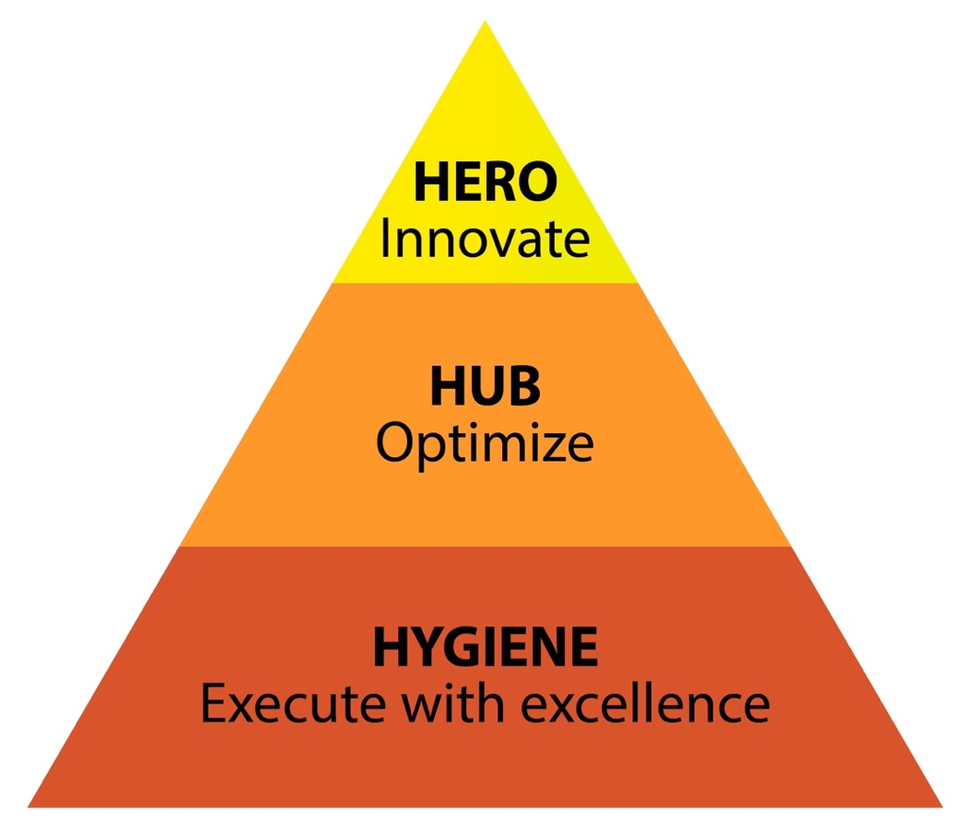

Prioritize Tactics – Investment/Impact
Use the investment/impact chart to graph your activities. Be as realistic as possible about both the investment and the size and scope of the impact. Remember the hidden costs, unexpected technical issues and running costs of implementing a digital marketing tactic.

Plot all of your activities on the Investment/Impact graph to further bring clarity to how you can better focus your efforts.

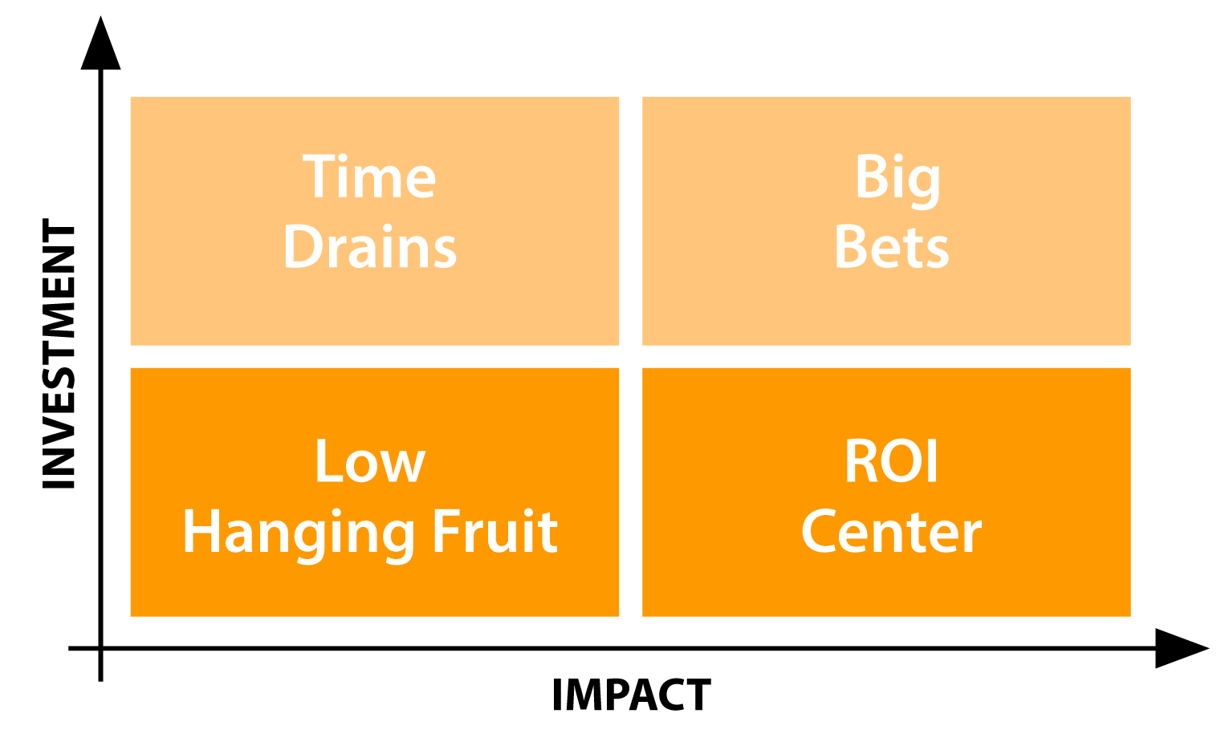

Power Tip:
Prioritize your plan based on your resources as well. Consider if you will insource or outsource each activity as a part of the prioritization process.

One Page Digital Marketing Execution Plan
My primary goal for using digital marketing is:
________________________________________________________________________
The digital strategies I will use to achieve this goal are:
- _____________________________________________________________________
- _____________________________________________________________________
- _____________________________________________________________________

The people I am trying to reach are:
________________________________________________________________________

My Prioritized Plan is:
Immediately –

Short-term (next 3 months) –

Medium-term (3-6 months) –

Long-term (6 months+) –

Step 7: Measurement
Strong measurement starts with strategy. Without knowing WHY you are doing something it is impossible to measure if it is effective. Many issues in digital marketing effectiveness and execution stem from unclear Goals, Strategies and Objectives.

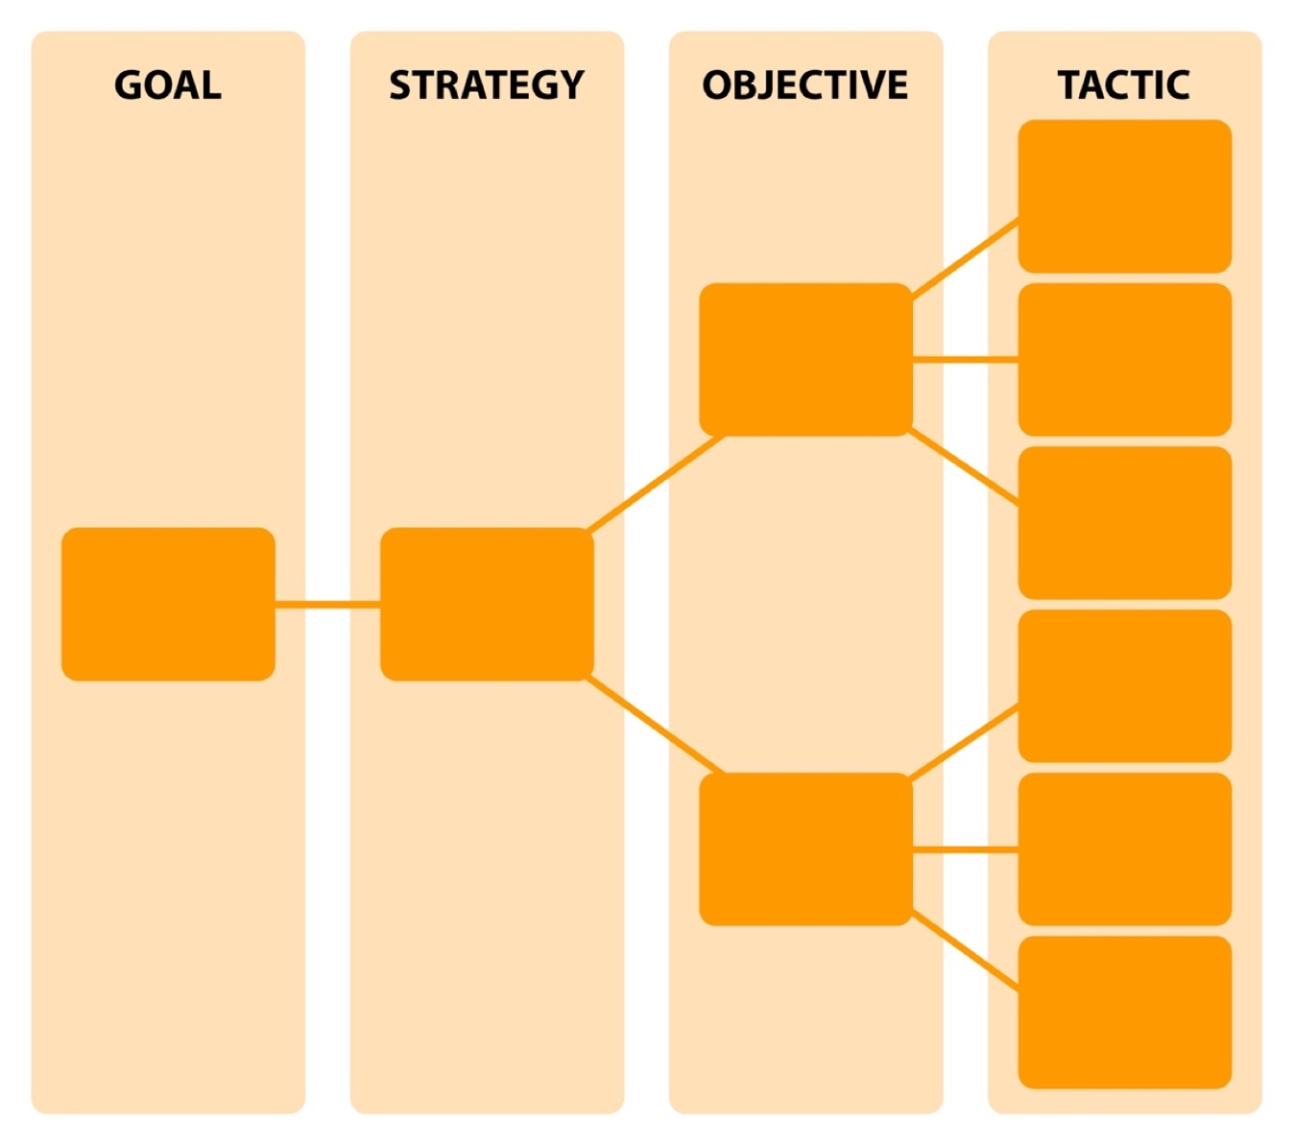
Link your KPIs to your execution – each digital marketing execution should have a clear KPI of what you are trying to achieve and how you will measure success. Remember to set Quantity, Quality and Cost KPIs (or use a single metric that incorporates all of the above).

Digital Reporting
Reporting on your results helps you to stay focused and understand if you are getting the results that you expect from your efforts.

What is the purpose of your report?

Who is the audience for your report?

How often will you report?

What are the key metrics to be incorporated into the report?

ROI and Value of Investment
If you have clearly defined KPIs that link back to your business objectives, it often isn’t necessary to do additional ROI or value of investment calculations. That being said, for large investments or new ideas it is often helpful to do some type of value analysis to be sure that you are generating sufficient value from your investment.

How can you calculate the value of your investment? Can you compare investments to each other with comparable methodology?

Which investments require a value calculation?

How can you improve ROI for your existing investments? Is this mindset a part of your digital marketing operations?

- Investment:
  - Reduce time spent with tools and processes
  - Reuse and repurpose content
  - Determine what something is “worth” and set a budget
- Return:
  - Test and learn to improve over time
  - Analyze results to grow
  - Increase your reach since your investment in content is fixed

Step 8: Optimization
Optimization of digital marketing is about regularly evaluating your digital marketing efforts and adapting your plan and execution to maximize your results. While reporting usually focuses on sharing results within an organization, analytics and optimization is about the going practice of informally reviewing results and adapting your strategy and execution as needed.
Power Tip:
Even though you have a well thought-out plan – if you aren’t getting the results you expect from it you should adapt your plan accordingly. Let results and data guide your decisions.

Build Your Analytics Rhythm
How often will you analyze the results of your digital marketing executions?

What will you look for in your analysis?
Power Tip:
Use the What -> So What -> Now What framework to maximize the impact.

What data sources will you use to validate your assumptions and performance?

What changes can you make based on your results? What changes do you need to seek approval for?

